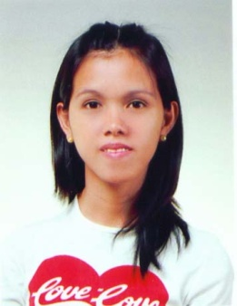

MARY GRACE B. GARRIDO

505-1704 Woonam Firstville 905 Shinbong-dong, Sujigu Yonginsi Gyeonggi-do

E-mail : gracegarrido_10@yahoo.com

H.P. : 010-4515-6559
OBJECTIVE:
To obtain professional position where my education and experience will contribute to the success of the school and pupils, and impart knowledge to them.

WORK EXPERIENCE:

Byeongjom Elementary School

After School English Teacher

March 2009 – January 2010

Bagong Nayon II Antipolo Christian School

Pre-school Teacher

Elementary Science Teacher

June 2005 – March 2008

EDUCATIONAL BACKGROUND:

Bachelor of Elementary Education

University Of Rizal System, Cainta Rizal

Graduated March 30, 2005

SEMINARS ATTENDED:
3rd Annual Leadership Training
Hinulugang Taktak National Park Antipolo City
March 7-8, 2002

4th Annual Leadership Traning
Tahanang Walang Hagdan Inc., Cainta Rizal
February 19-20, 2003

5th Annual Leadership Training Seminar
Antipolo Paenan Camping Farm
February 27-28, 2004

Seminar on Teaching Strategies

University of Rizal System

March 10, 2004

Student Teacher Enhancement Program

University Of Rizal System Cainta Rizal

November 3-10, 2004

School Based Seminar-Training Program

Golden Sunbeam Christian School, Antipolo City

July 23, 2005

Seminar Workshop on Developing a Learning Environment for Preschool Children

Harris Memorial College Conference Room

August 27, 2005

ACSAC Teachers Lecture Seminar

Golden Sunbeam Christian School, Antipolo City

July 26, 2007

AFFILIATION:

*BOARD PASSER OF LICENSURE EXAMINATION FOR TEACHERS

APRIL 2008

REFERENCE:

References furnished upon requests

PERSONAL DATA:
* Nationality: Filipino
* Available date: 3rd week of March
* Date of birth : July 10, 1983
* Preferred Location : Suji, Suwon or any
* Expected Salary Range: its up to you
* Preferred teaching age Elementary:
* Available time for us to call: Anytime of the day
* Tel # that We can reach or Skype ID: My skype ID gracejeoun
* E2 visa documents that you have Now: Currently I have F21 visa

