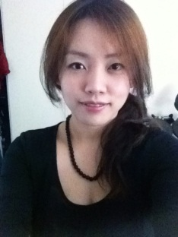 Stella Kim

Yookim8282@hotmail.com mob: 0424 306 119

4/39 David St. Nundah QLD 4012

Profile
Born in South Korea and immigrated to Australia 1996. (Australian Citizen)
Self-motivated, organized, competent and enthusiastic person who can learn quick.
Honest, confident, hardworking leader, a person of keen judgment with a record of integrity and dependability.

Date of Birth
01/08/ 1982

Education
- Master of Education 2012-ongoing as worldwide internet based study.
University of Southern Cross
- Bachelor of Visual Arts 2005-2010
University of Southern Cross
- Cheltenham Girls High School 2001

Experience
- Visual Art student teacher for year 10 and 11 at Upper Coomera State high school 2007
- Visual Art student teacher for year 8 and 9 at Lakeside Christian College 2006
- English teacher at Kyohaksa English Academy in Suwon, South Korea 2004
- English teacher at Ehwa English Academy in Dong Suwon, South Korea 2003
- Receptionist C & S Fabrication in Silverwater Sydney 2002
Answered telephones, scheduled boss’s appointments, received and delivered messages, processed incoming/outgoing mail, received faxes from other company for quotations, filed all forms, calculated all the prices and quotations, opened office in the morning and maintained reception area.
- Waitress at Pinocchio Korean Restaurant in Labrador Sydney 2001
- Waitress at Yookee Sushi Bar in West Ryde Sydney 2000
- Short work experieces at Fresh Juice shop, belt shop(Sydney City), T-shirt shop(Sydney Flemington) and Chinese Restaurant 1999-2002

Computer skills
- Extensive knowledge of internet technology
- Knowledgeable in Microsoft ( Word, Excel, Powerpoint) and Adobe Photoshop

Additional Information
- Fluent in English and Korean

