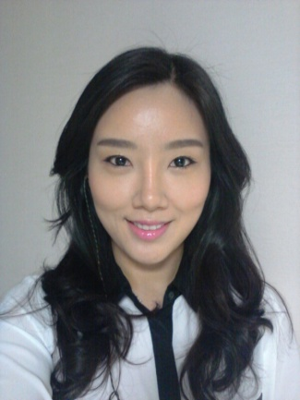

Victoria Kang
101-303 Hanyang Sujain, 601 Boradong, Kiheung, Yongin, Kyunggi
010-3352-8211
vkang0228@hotmail.com

"Passionate, Creative and Dedicated Teacher Seeking for English Teaching Position"

HELLO!

First I would like to thank you for taking time to read my resume. My name is Victoria Kang and I am one of the candidates who is seeking for a position at your institute. To tell you a bit about myself, I am a 29 year old, single, and charismatic Korean-Canadian who grew up in Toronto. I was born in Korea and had moved to Canada in early elementary. I do speak Korean fluently since I grew up in a very family-oriented environment where Korean culture set strong.
As I matured as a student, I always had passion for the arts and decided to study business of fashion in university. After finishing my studies, I decided to move back to Korea to broaden my culture and potentially start a career. Interestingly, the very first job I took was a teaching position at Jongro M School in 2006 and I've been teaching ever since!
I strongly feel for ESL students that it takes more than hard effort to be a successful English learner. I believe the most important element is the motivation and my job is to elevate it so that the students will be enthusiastic and have fun when learning English. I can easily relate to students and create special bonds and connection with them. I'm determined to create an organized, educational and exciting classroom which will be enjoyed by all students.
Please refer to my resume for further qualifications. I can assure you that if you decide to add me on your team I would be an excellent asset. I am looking forward to hearing from you in the future, and I hope that we will be able to meet in person and discuss about the position!

QUALIFICATIONS

- Have strong dedication to students' development and to their educational needs
- Utilize modern teaching methods such as Powerpoints, e-learning and team learning
- Possess self-motivation, patience and high level of energy
- Have extensive experience in teaching adults as well as children
- Have fluency in Korean and English language in both forms- verbal and written
- Excellent speaking, writing and communication skills with the ability to effectively work with others
- Achieved TESOL certificate of 100 hours
- Strength in organizing, planning and responding to people with kindness
TEACHING EXPERIENCES

‘Bu Yang Elementary School’ Sutaek, Guri (FT) 2010-2012

‘Avalon' Seocho, Seoul (FT) 2008-2010

‘GKI School’ Pungnap, Seoul (FT) 2007-2008

‘Jongro M School’ Shinchon, Seoul (FT) 2006-2007

‘LG Electronics @ Twin Tower’ Yeoido, Seoul (PT) 2006-2008
(Corporate part time teaching)

EDUCATION

Obtained Bachelor's Degree in Fashion Management from York University, Toronto, in the year of 2005

Nancy Campbell Collegiate Institute, Stratford, Ontario

REFERENCES AVAILABLE UPON REQUEST

