Thomas Douglas
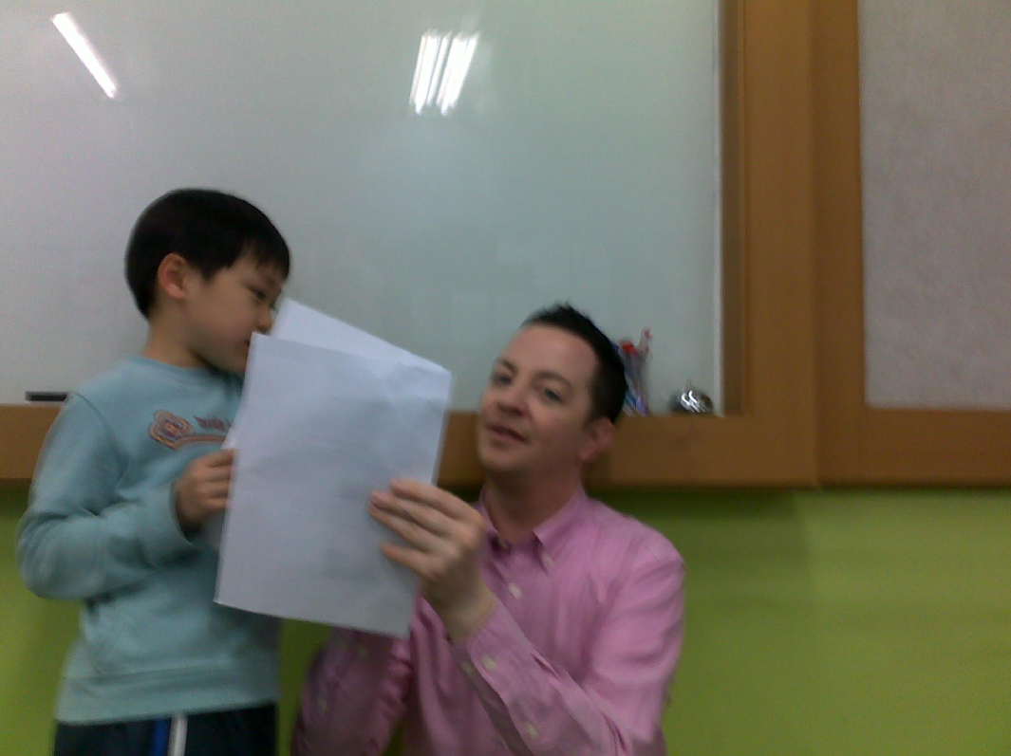

Address:
24-19 Itaewon Dong, Yongsan Gu. South Korea
Contact details:
Cell: 010-5755-9218
Email: tjdoug@hotmail.com
Nationality:
BRITISH

Personal Profile:

- A logical thinker, who welcomes responsibility, is organised and effective first time
- 3 years teaching experience

Professional experience:

Yongdo Elementary School, Mokdong, South Korea March 2011- Present

- Teaching English to children from the age of 8-14 years old
- Working alongside a Korean co-teacher
- Maintaining communication between teacher and children’s parents
- Testing children on their abilities in English vocabulary and verbal skills.
- Preparing and delivering test papers

Sahmyook Elementary School , South Korea April 2010- March 2011
- Teaching English and Maths to children from the age of 8-14 years old
- Working alongside a Korean co-teacher
- Compiling reports to be supplied to Principle and Head Teacher
- Maintaining communication between teacher and children’s parents
- Testing children on their abilities in English vocabulary and verbal skills.
- Preparing and delivering test papers

Volunteer, Arbroath, UK April 2009- March 2010
- Meet the general public during the Centre opening hours, offer advice and re-home cats that match their needs.

Hammondsdirect, System Admin Manager August 2005-Nov 2008
Bradford, West Yorkshire, UK
- Oversee day-to-day operations of the Systems Administration Department (8 team members in Bradford, UK including 1 Team Leader & 3 in Mumbai, India)
- Training and support staff to achieve high levels of service and quality
- Interviewing and recruitment of Team Leaders and Administrators
- Hammondsdirect Staff Forum - Vice-Chairman
- Employee of the Month – Panel Member

Significant Achievements:

Institute of Leadership & Management

- Introduction to First Line Management (Level 4) 2005
- Certificate in First Line Management (Level 5) 2006

Both of the above courses were on day release, once a month from work duties, whilst at Hammondsdirect. Each lasted for one year at BTAL Bradford. Topics included Communication, Managing People, Managing Resources and many others. Both courses were passed above 85%.

WSET.
Advanced Certificate in Wines and Spirits. Level 1-3
Diploma in Wines and Spirits Level 4

Provide expert knowledge of the principal wines and spirits of the world combined with commercial factors, and a thorough system for the professional evaluation of wines.

Education

B.Sc (Hons) Psychology & Sociology
2 ‘A’ Levels Geography & Psychology
1 ‘AS’ Level Sociology
9 GCSE’s Grade C+ (Including Maths, and English Lit & Lang)

References available on request

Hello, I saw your advert on the hiexpat website and would like to be considered for the positions. I have included my resume and and have 3 years teaching experience. My phone number is 010 5755 9218.
Thank you and look forward to speaking to you soon.

