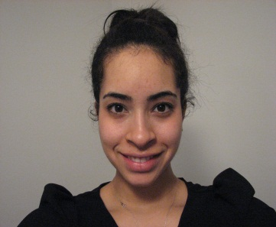
Maxima Ornelas
Meeornelas04@gmail.com
5920 Andover Dr. Apt 24
The Colony, TX 75056
(219)-713-8610

Citizenship: USA
Age: 24
Marital Status: Single

Objective Overview
TEFL certified, college graduate who is a hardworking individual seeking a teaching position in South Korea. Looking for a challenging school that will further my teaching skills and experiences.

Education and Certification

International TEFL Academy Chicago, IL, USA
TEFL/TESOL Certificate September 2013
- 180 hours of course work
- 10 hours of student teaching practicum

Indiana University Bloomington, IN, USA
Bachelors of Arts and Science May 2013
Major: Spanish
Minor: Eastern Asian Studies

Related Work Experience

Practicum hours
International TEFL Academy 2013
- Created lesson plans for classes that were an hour and a half.
- Taught Beginner, Intermediate and Advanced adult students.
- Was observed by a certified TEFL instructor while teaching, and was given feedback on lesson.

Tutor
Indiana University 2010-2013
- Met one on one with international students at the library or their homes.
- Helped international students (from the ages of 18 to 40) with corrections on written assignments (essays, journals, resumes, and professional letters)
- Held conversations to assist with pronunciation and word selection
- Assisted international students with development of presentations (Informative speeches, music theory and sales presentations)

Practical English Tutorial (P.E.T)
Indiana University 2012
- Attended organized tutoring through Indiana University’s International service program.
- Met with international students (freshmen to graduate students) every Saturday at the Indiana University International Center to help with oral skills.
- Conversed with international students to assist in one-on-one and group discussions
- Provided tutoring on conversational articulation and self-expression
- Facilitated discussions on a diverse number of topics

Additional Work Experience

Receptionist/Direct Care June –August 2013
Great Lakes Regional Care Battle Creek, Michigan
- Copied and filed important paper documents
- Organized and created documents on the company’s file repository system
- Worked with residents who have mental illness and disabilities
- Chaperoned resident field trips
- Administered and verified residents were taking their daily medications
- Took First Aid and CPR training

Crew Member 2011 - 2013
Chipotle Bloomington, Indiana
- Accepted customers’ orders from the front counter and over the phone
- Prepared entrees according to corporate standards and customers satisfaction
- Handled cashier duties
- Performed sanitation duties to keep up with public health and corporate standards
- Trained new employees on front line and cashier positions
- Learned about company history and offered products

Skills
- Computer skills: Windows 7, XP, Microsoft Office (Word, Outlook, Excel and PowerPoint)
- Strong written and verbal communication skills
- Understanding of cultural differences
- Fluent in English and Spanish languages
Additional Experiences and Activities
Volunteer in the International Community 2011-2013

- Facilitated international events by serving food, performing, and answering questions
- Tutored international students in reading, writing, and comprehending the English language/American culture
- Volunteered as a language partner/speech trainer
Student Ambassador for People to People 2005
- Traveled abroad to study other cultures in Europe (UK and Ireland)
- Lived with a host family and immersed myself in European cultures to gain further enlightenment and understanding in the UK and Ireland
- Traveled around the UK and Ireland to educate myself on European history through guided tours

