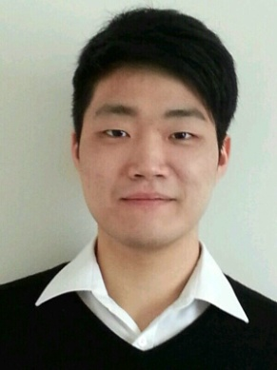

Seung Han (Eddie) Kim

Residency: New Zealand Citizenship

Education
2009 – 2013 University of Canterbury
Bachelor of Science, majoring in Statistics
2004 – 2008 Christ’s College
NCEA Levels 1, 2 & 3.

Key Skills and Competencies

Interpersonal Skills
- Working at Crescent Jewellery and Van Roli Ltd. developed excellent customer service skills, especially being well mannered and polite, and an ability to get along with many different types of people
- An appreciation of and sensitivity to the many differing perspectives on the world through making many friends from multiple cultures
- An ability to relate well to people and help them cope with new situations as shown by mentoring other students in the UCKA (University of Canterbury Korean Association) club at university

Communication Skills
- Clear, high quality written communication as demonstrated by achievement of A average grades in essays and reports for Water Resource Management and Forestry university courses
- Effective listening and oral communication skills developed through delivering presentations at university, mentoring other students and retail work
- Successfully adapt to both Korean speaking culture with Korean friends and English speaking culture with New Zealand friends

Teamwork Skills
- At each workplace, made a positive contribution to the work environment by being reliable, flexible, supportive and friendly towards colleagues
- Longstanding commitment to being a team player and ability to develop teamwork in others through playing in a rugby team at high school and indoor soccer at university

Problem Solving Skills
- Managed customer complaints/returns in retail roles by listening, ascertaining the problem and finding an appropriate solution, liaising with the manager when necessary
- Analysed the student’s performance in exams and specifically focused on overcoming the student’s weaknesses as part of my responsibilities as a tutor

Achievements
2008 Christ’s College Rugby 1st XV and 2nd XV
2008 Corfe House Prefect
2004 – 2008 Somes Exhibition Scholarship

Employment History
July 2012 – Van Roli Ltd. Apparel Distributors
- Accurately picking and dispatching stock from orders
- Controlling stock to advise on future orders
- Delivering and picking up apparels needing repair

Aug 2011 – Nov 2011 NCEA Level 1 & 2 Maths tutoring
- 1 on 1 tutoring for 90 minutes twice a week

Dec 2009 – Feb 2010 Parex International Co Ltd.
- Helped processing deer velvet (temporary summer holiday job)

Jan 2008 – Feb 2009 Crescent Jewellery
- Customer service and handling cash (cash register & EFTPOS)

Interests
- Korean culture – member of UCKA (University of Canterbury Korean Association) club at university from 2011 – 2012
- Playing social baseball and indoor soccer once a week

Referees
Name Dr Rachel Wright
Science and Entrepreneurship Course Lecturer
College of Science
University of Canterbury
Tel +64 27 512 4894
Email rachel.wright@canterbury.ac.nz

Name Jake Cantwell
Manager
Van Roli Ltd.
Tel +64 3 366 2785
Email jake@vanroli.co.nz

