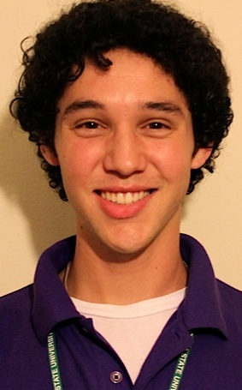

Scott Lozano
EMPLOYMENT HISTORY:
6th and 7th Grade Science Teacher 08/12 — Present
Employer: Jackson Public Schools (JPS)
210 Daniel Lake Boulevard Jackson, MS 39212
Salary: $32,000, 40+ hours/week
Supervisor: Mr. Kriag Ficken
- Creating activities, exercises and educational programs and facilitating them with targeted populations.
- Identifying and recruiting volunteers for special events and projects
- Finding and maintaining lines of contact with donors and advocates to meet student needs and in support of student families with extra-circumstantial needs.
- Planning and implementing outreach programs to support needs of targeted communities
- Managing multiple projects and creating or adapting curricula as part of a team.
- Researching and seeking media placement and enrichment for organizations
- Communicating with individuals of varying backgrounds and sophistication
- Excellent public speaking and communication skills.
- Creating curricula and leading science club, where students can receive tutoring help and conduct experiments to apply knowledge of scientific principals such as building water pressure rockets and robots.
- Coach of the school soccer team as well.
- Responsible for maintaining consistent parent and advocate contact on the status of a child’s well-being.
- Responsible to assist students who are in extra-situational need of assistance.
Responsible for documentation and follow-up for behavior management plans, documentation of interventions used on a student’s behalf and remediation for students who are behind academically
- Designing and facilitating age-specific programs and activities.
- Managing databases.
State Department Oct.-Dec. 2011
Environment, Science, Technology and Health Section (ESTH)
Employer: U.S. Department of State
Salary: $1,000 per month.
U.S. Embassy in Moscow, Russia
- Working in a position similar to that of an entry level Foreign Service Officer.
- Researched, monitored and drafted reports on the development and use of the Russian internet and social media platforms in order to seek media placement and enrichment for State Department use.
- Created reports and briefed visiting diplomats and ESTH personnel; edited drafts and assisted multiple sections’ personnel in seeking grants and drafting reports and researching topics of interest.
- Met with various Russian government and non-government institutions and businesses to gather policy and development data and analyze that data and enhance Russo-American business relations.
- Acted as translator/minutes keeper for events in Russian; Translated documents in Russian; monitored Russian news
- Assisting in the creating and implementation of grants and contracts.

Foster Business Library Staff November 2008- June 2012
Employer: University of Washington; Seattle, WA
Paccar Hall, 1st Floor Northeast Stevens Way, Seattle, WA 98195
Salary: $9/hour (26 hours per week)
Supervisor: Mr. Dan Halligan, (206) 543-4360, May be contacted.
- Customer Service and administrative position assisting library patrons finding information and using library materials.

Inyo Desert Restoration Crew Member July- September 2009
Employer: Student Conservation Association
Mammoth Lakes, CA
Supervisor: Jamie Weleber
- Restoring over 30 negatively impacted forest sites
- Assisting USFS service members implement restoration projects
- Working with a team of 9 to organize food and equipment and plan restoration projects in partnership with the USFS
EDUCATION and QUALIFICATIONS:
University of Washington September 2008 - June 2012
B.S. Degree (GPA 3.46)
Kentridge High School
Diploma
SKILLS:
PC and Macintosh Operating Systems, Microsoft Office, Outlook, Social media, Russian Language (fluent), Grant Writing
COUNTRY EXPERIENCE:
Russia: Moscow, Tver and St. Petersburg

LANGUAGES:
Russian: Full professional Proficiency
Spanish: Basic working knowledge
English: Native

VOLUNTEER EXPERIENCE:
Dream Project Mentor, 1/11 — 06/12
University of Washington Dream Project Mentors, Seattle, WA 98195, 3— 10 hours per week
- Worked as part of a team to fundraise, organize events, create and advance donor databases, identify and recruit volunteers as well as organizing volunteerism.
- Assisting under- privileged high school students and their families seeking college education through scholarship finding, tutoring, and application assistance.
- Creating and utilizing donor databases and community resource directory.
- Expanding corporate sponsors and increasing awareness of organization missions.
- Supporting community fundraisers and organizing them.

INTERESTS:
- Surfing, hiking, running, cooking, gardening, cutting hair, writing

