Ryan Singer

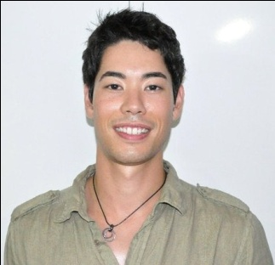

524 Hanam Livingtel Bldg. #509, Shinjangdong Hanam-si, Gyeonggi-do

Email: rjsinger@gmail.com • Mobile: +82-10-8313-1312

Education

2002-2007
University of Guelph, Guelph, Ontario
Bachelor of Science
•Major in Biological Science

Professional Experience

March 2010 – Present
American City English Village, Hanam-si, Gyeonggi-do, Native English Teacher
Duties performed:
•Homeroom teacher, Science Teacher
•Developed curriculum based on American textbooks
•Created and prepared classroom materials for various class types including science, physical education and art.
•Decorated and managed classroom on a weekly/monthly basis
•Rode school bus to accompany students to and from school
•Supervised and interacted with students on a variety of field trips
•Public relations and recruiting

June 2009 – March 2010
Stars Men’s Shops, Sales Associate
•Informed and advised customers on dress and formal clothing
•Provided personal and attentive service to customers
•Completed and maintained inventory and financial paperwork

Sept 2006 – Dec 2006
University of Guelph
•Assisted exchange students working in labs with English skills

July 1999 – August 2007 (Summer Contract Position)
Priestly Demolition, General Laborer
•Trained students employed for the summer on the safe operation of machinery and equipment

January 2002 – June 2002
OAC Calculus, Tutor
•Tutored grade 10 and 11 students in math

October 1993 – June 1994
Peer Helper Program, Peer Helper
•Created games and activities to assist younger student’s reinforcement of reading and writing

Language Skills
•Fluent in English
•Proficient French
•Basic German

Relevant Skills
Computer skills:
•Microsoft Word, Excel and Power Point
•13 years of guitar playing and vocals in various bands/groups
•Wide array of musical skills and knowledge

References

Bang Mi Jin (Rebecca)
Educational Co-ordinator
American City English Village, Hanam-si
+82-31-795-5993

Jennifer Lee
Native English Teacher
Seoi Elementary School, Gangnam
(010) 5520-2610

Greg Grasso
Native English Teacher
American City English Village, Hanam-si
(010) 2609-9449

Toni Naso
Manager
Star’s Men’s Shop, Newmarket, Ontario, Canada.
+1 (905) 830-0310

