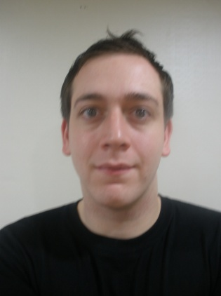
Michael Radford
21st November 1985
Kang Nam Office Town #417
Keayang Gu
Incheon City
South Korea
Telephone: 010-5777-9529
E-mail: michaelradford@fsmail.net

Education & Qualifications

2007 – 2008
Sheffield Hallam University
MSc International Marketing Masters
Awarded PGDip

2004 – 2007
University of Sheffield
BA Business Studies Degree.
Awarded BA Honors

2002 – 2004
Parrswood Technology College, Manchester: 3 A-Level’s
Awarded 3 A-Levels: Media Studies B, Business Studies C, Politics C.

1997 – 2002
Parrswood high school, Manchester: 9 GCSE’s
Awarded 9 GCSE’s: Maths A, Business Studies B, Media Studies B, English Language C, German C, Duel Science C (2 GCSE’S), Religious Education C, Resistant Materials C.

Employment History & Work Experience

June 2009 – September 2009
English Teacher, Herald School, Incheon City, South Korea

Responsibilities Included: Teaching Kindergarten and elementary children English, Science, Art, Math and Drama using games and songs that made the learning experience fun.

November 2008 – May 2009
English Teacher, GnB English School, Incheon City, South Korea

Responsibilities Included: Teaching kindergarten and elementary students grammar and language skills using books and external stimulus such as flash cards, songs, games and other material.

November 2008 – May 2009
English Teacher, Yong Hwa Kindergarten, Incheon City, South Korea

Responsibilities Included: Teaching basic English such as the alphabet, days of the week and the weather using games and other fun methods that interacted with the children and made learning English fun.

April 2008 - July 2008
Barman, Mercure Hotel, Sheffield

Responsibilities Included: Serving customers with drinks and food, changing barrels and stocking shelves, cleaning the bar and other areas of the pub, cashing up the till and being in charge of handling money.

December 2002 – April 2005
Waiter, Barman, Kitchen Assistant, Weatsheaf Hotel, Baslow

Responsibilities Included: Serving customers with drinks and food, changing barrels and stocking shelves, Washing dishes, making and preparing starters and deserts, cleaning the bar and other areas of the pub and being in charge of exchanging money.

Interests & Achievements

In my spare time I enjoy watching football and cricket and represented Sheffield University cricket team during my time at the University. When I am not studying or playing sports, I enjoy listening to music and playing the guitar, along with socializing with my friends. I also have a passion for travelling and sampling other cultures.

References

Available on request

