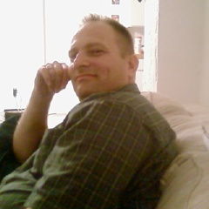
Resume Philip William Nason, Sr.
3015 S. 75th St., Tampa, Florida 33619
(813) 777-8921
Keywestdad2098@yahoo.com

Education:
Stetson University, Deland, FL. B.A. Religion. 1978-1982.
Southern Baptist Theological Seminary, Louisville, KY. M.Div. 1982-1985.

Family:
Married to Robin Nason since May 16, 1981
Two Children: Samyra (age 26) and Philip Jr., (age 24).

Reason I want to come to Korea:
My wife and I desire for each other to explore our potentials. She is giving me the opportunity to teach in Korea as a way to develop a more rounded life experience and to help other people to live a more productive life. Possibly, after a year in Korea, she might be able to join me for a second year.

Work Experience:
Florida Department of Corrections, Probation and Parole. 1998 until the Present.
In this capacity, I have worked with the non-prison population of adult and some juvenile criminals. I have worked with them as a Substance Abuse counselor, Case Manager, Life Skills Manager, Court Officer, and Monitoring compliance with the Conditions placed on them by the Courts.

Substance Abuse Counselor, Bridges of America, Orlando, FL. 1995-1998.
In this capacity, I have worked with the prison population of adult men and women. Rehabilitation has been the emphasis here. I have been a Counselor, as well as a supervisor of other counselors.

GED Adult Education Teacher, South Florida Community College, Avon Park, FL. 1994-1995.
In this capacity, I taught the GED curriculum to adults. I also taught the Advanced Driver Education program to adult men and women.

I also taught local Community College courses in World Religions a couple of semesters over the past few years.

Throughout all of this timeframe presented, I also pastored local churches since 1982. I currently pastor the Causeway Baptist Church, Tampa, FL. I have done this along with my work as a Probation Officer for the past 2 ½ years.

References Available Upon Request.

I have no Criminal Violations on any record.

