RESUME |  |  |  |  |  | 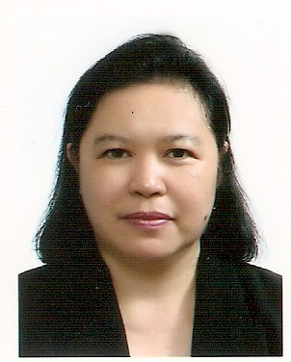
Name | Juliet Bacamante
Date of Birth | 1965.05.06 |  | Citizenship |  | Filipino
ID NO. | 650506-6100297
Address: | 서울 성북구 성북동 115-9
e-mail | julietbb2001@yahoo.com |  |  | PHONE |  | (mobile) 010-5785-4271
Home address | 1159 Lapu-Lapu Superhighway, Aplaya, 8002 Digos City, Philippines  ☎(+63)9192545267
Education | 1988  2008 | Bachelor in Secondary Education major in Mathematics, University of Southern Mindanao, Kabacan, Cotabato, Philippines  Master of Arts in Pastoral Studies, Ateneo de Manila University, Philippines
Formation | 1991  1997 | Philippine Lay Mission Program, (Maryknoll Fathers), Shrine Road, Matina, Davao City, Philippines  Columban Lay Mission Program, (Columban Missionaries)  34, Rosario Drive, Quezon City, Philippines
Training/  Seminar  _________  Work Experience/Ministry | 1990  1990  1992  1993  2001  2005  2006  2006  2007  2008  _______  1988- 91  1996-97  1991-96  2008.6-12 | Secondary Education Development Program - Davao del Sur National High School, Digos City, Philippine  Leadership Training-Davao del Norte School of Fisheries, Panabo City, Philippines,  Catholic Lay Evangelization - San Carlos Compound, Guadalupe, Makati, Philippines.  Counseling for the Poor - Ugat Foundation, Ateneo de Manila University, Philippines  Exodus: Formation Week for Pastoral Workers with Migrants in Asia – Tagaytay, Philippines  Philippine Migrants Rights Watch - Manila Philippines  [East Asian Pastoral Institute, Ateneo de Manila University]  Pastoral Renewal Program  Effective Steward Leadership  Pastoral Management Workshop  Spiritual Direction Workshop  Media and Pastoral Ministry Workshop  ____________________________________________________  (Philippines)  Teaching :  Davao del Norte School of Fisheries, Panabo City, Philippines  Rizal Central Elementary School, Mt. Apo District, Digos City  Lay Mission :  Community Organizing (Basic Ecclesial Community organizing)  Animation :  East Asian Pastoral Institute, Ateneo de Manila University,
Ministry / Work / Activities in  Korea | 1997  1998-2004  2009.3-12  2009.5-10  2010.1 to  present | Invited by the Columban Missionaries in Korea  Korean Language Studies (up to 3rd level), Sogang University, Seoul Korea  Migrant Ministry, Urban Poor – Seoul, Korea with the Coulmbans  Invited by Masan Diocese, Korea  Migrant Ministry, Changwon Migrant Center, Masan Diocese  Teaching English, in Changwonsi, GyeongNam  Migrant Ministry, Hyehwadong Filipino Catholic Center, Songbuk  Villa, 115-9 Songbuk 1 Dong, Songbuk-Ku, Seoul  English Teaching
Languages | (1) Cebuano (2) Filipino (3) English (4) Korean
I hereby certify that all the above statements are true and correct to the best my knowledge
2010. 09.2

JULIET B. BACAMANTE

