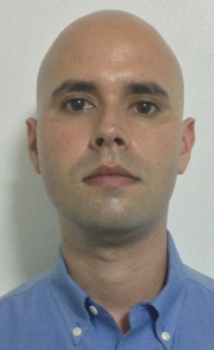
OMAR TOSCA

PROFILE
I am a 160 hours course Professional TEFL Certified English Teacher. A native English speaker
and I also speak Spanish as a second language. I hold a BA in Digital Graphic Design
and currently seeking job openings in Asia. My goal is to improve student’s abilities to perform in
all English skills required using my knowledge as a TEFL Certified Teacher.

EXPERIENCE
NEXT GEN. BILINGUAL ACADEMY, HATILLO, PR — MARCH 2013 - APRIL 2013
Substitute English language teacher at a private bilingual academy for students from kindergarten
to 10th grade. Taught kindergarden at beginner levels and elementary at intermediate levels.
Further developed experience working with handicapped students.

NEXT GEN. BILINGUAL ACADEMY, HATILLO, PR — FEBRUARY 2013 - MARCH 2013
40 hrs Practicum with beginner level students. Develop experience working with handicapped
students.

FREELANCE DIGITAL GRAPHIC DESIGNER, PR — 2002 - PRESENT
Development of publicity campaigns for customers such as Amgen Pharmaceutical, Johnson and
Johnson Pharmaceutical, Pfizer Pharmaceutical among many others. Creation of corporate
image for medium sized and start-up companies.

EDUCATION
Atlantic University College, Puerto Rico — 2013
- BA in Digital Graphic Design

TEFL Institute —2013
- Professional TEFL certification as a teacher of English as a foreign language. The course
included practice and input sessions.

SKILLS
Bilingual American citizen fluent in English as a native language and Spanish as a second
language. Being bilingual makes it easy for me to relate to students and motivate them to learn
and study regardless their language level. I am a very adaptable person who is able to live in
diverse places for prolonged periods of time. I can work well with computers and technology
devices focused on student teaching.

REFERRALS

Available upon request

