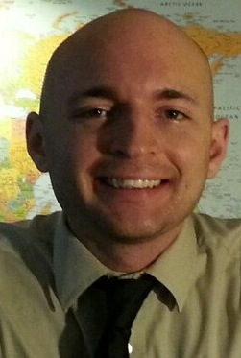

NICHOLAS J. GIUSTI

Objective
To seek a position that will allow me the opportunity to further expand my education and knowledge so that I can build a path to a successful career.

Education
University of Central Florida, Orlando, FL 09/09-
- Bachelor in Health Science present
Overall GPA: 3.1/4.0
Degrees expected: August 2013

Florida State College Jacksonville, Jacksonville, FL 09/07-
- Associate in Arts Degree earned 08/09

Certifications
- Trained and Certified Nursing Assistant 10/10
  - Perfect C.N.A. Training Academy
- Basic Life Support Certified 03/12
  - American Heart Association
Skills
- Experience with working with those in need of help
- Experience with methods of teaching
- Good with communication and demonstration
- Can demonstrate strong analytical and problem-solving abilities
- Proficient in the use of computers including Microsoft Word, PowerPoint and Excel software applications.
Experience
• Certified Nursing Assistant
- Life Care Center of Orlando 03/12- 05/13
- Chemistry Tutor
- SARC TUTORING LAB 10/10-
05/11
- Teachers Aide 2011
- Sales Associate
  - Target Department Stores, Jacksonville, Florida 10/07- 08/09
Activities / Volunteer Work
• Clubs: Honorary Member of Pre- Professional Medical Society 2011
• Volunteer at Disney Florida Hospital for Children, Orlando, FL 2011

To whom this may concern:
I have a very strong interest in pursuing a teaching career. What made me enjoy teaching was when I first started doing private tutoring for both high school and college students. I enjoyed my time with the students and was able to create a fun atmosphere that kept them coming back for more.
My first classroom teaching experience was as a volunteer elementary school religion teacher at a local church where I worked for two years during my years in high-school. And in college I was a volunteer at Disney Children’s Hospital in Orlando Florida to young children. I also was a professor’s aide at the University of Central Florida.
My real teaching experience though came from tutoring students in high school and in college. I particularly enjoyed working with younger adults and liked preparing lessons that allowed me to break down sometimes complicated concepts to simple examples that my young students could grasp.
Managing the difference of abilities among my students proved a difficult, but satisfying, challenge. I tailored my activities to maintain the interest of high-level students that made the classroom fun and enjoyable.
My resume is enclosed. I look forward to speaking with you.
Thank you for your consideration.

