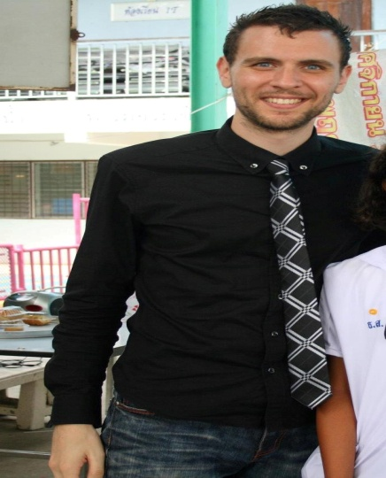

Michael J. Carey
124 Sukhumvit Soi 38
Bangkok 10110, Thailand
MJCarey465@aol.com

Education

Carleton College, Northfield, MN 9/99-6/03
Bachelor of Arts (B.A.), Mathematics / Economics
Graduated magna cum laude, with cumulative G.P.A. of 3.56.

Political Economy Seminar in Maastricht, The Netherlands 4/02-6/02
Visited and researched the operation of central EU institutions in Brussels, Luxembourg and Strasbourg.
Interviewed academics, government and business officials as part of research on state-industry relations and the economic effect of industrial networks in specific regions of Ireland and France.

Work Experience

Bangpleeratbamrung High School, Bangkok, Thailand 5/11-Present
Math Teacher
Develop curriculum for “Mini English Program”, in which gifted upper-level Thai students receive instruction for all subjects in English language.
Instruct students in subjects of Number Theory, Geometry, Algebra, Set and Logic Theory with emphasis on English vocabulary and communication. Produce daily written report for every class.
Devise all tests and exams in-house including mid-term and final exams; create in-semester worksheets and assignments using various sources. Administer individual speaking tests to all students.

Medical Resources Home Health Corp., Newton, MA 10/08-4/11
Human Resources Assistant
Conduct and review background checks including CORI, Nurse Registry and Sex Offender Registry checks, and conduct in-depth reference checks on 25-30 employment candidates weekly.
Create employee files, track and enter employee documents and credentials in Misys database, and maintain personnel files for over 800 employees covering 11 statewide offices.
Update and draft new human resource materials including employee application, employee handbooks, job descriptions, and emergency procedures.

Germaine Lawrence Inc., Arlington, MA 1/06-9/08
Assistant Residential Supervisor
Provide individual counseling to DSS-referred adolescent residents with emotional and behavioral difficulties.
Collaborate with mental health clinicians to develop specific treatment plans for individual residents.
Assist residents with daily living tasks and supervise daily leisure-time group activities.
Implement behavior management reward system to reinforce pro-social behaviors among residents.

Volunteer Experience

Circle Pines Center, Delton, MI
Workcamp Co-leader 6/03-8/03
Facilitated communication and cooperation between center management and international volunteer group, comprising volunteers from Italy, France, South Korea, and Germany.
Collaborated with international volunteers to develop and coordinate productive daily work projects with campers at the Center’s overnight summer camp.
Planned and coordinated periodic International Night events to allow volunteers to share their cultures with camp community.

Volunteers For Peace, Germany, France 8/03-11/03
Participated in three short-term International Volunteer Workcamps in Germany and France. Volunteer groups comprised 10-15 volunteers from Europe, Africa, Asia, Australia, and North America. Work included restoration of 900-year old castle, organic farming, and conservation projects on an environmental reserve.

