MAX ANDREWS
34 Samil-daero, Jongno, maxxocean@gmail.com Seoul, South Korea 010-509-56023
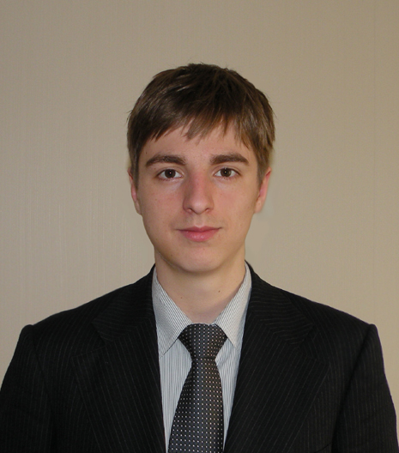
Qualifications Summary
- Conversational business teacher experience:
      - beginning, intermediate, and advanced levels
- Native English speaker and U.S. citizen
- TESOL 100 hours certificate completed
- 4 year dean’s list and university degree in Finance
- Enthusiastic, diligent, and responsible

Education
Northern Arizona University, Flagstaff, AZ
Bachelor of Science in Business Administration Graduation date:May 2012
- Major in Finance Cumulative GPA: 3.91/4.00

Funding Source: Grants, scholarships, financial aid, and part-time employment

Relevant Coursework:
- Business Communication: Effective business communication practices and conversation
- Critical Reading and Writing: Writing styles and grammar

Relevant Skills
Technical Skills:
- Operating Systems: Windows 98/2000/ME/XP/7; Macintosh
- Microsoft Office 2007: Word, Excel, PowerPoint
English:
- University level writing and business communication
- 100 hours TESOL certificate completed
- Teaching conversation English to adult learners

Work Related Experience:
- Held multiple conversation classes with business students throughout the day. The majority were group conversation classes ranging from 1-5 students, and several private 1:1 classes. Group classes consisted mostly of discussion topics from news articles based on student’s interests. Teaching style was student-centeredby interacting with other students and the teacher, as well as receiving active feedback for improvement. Private classes were on demand, ranging from business conversation, free-talking, news, videos, and pronunciation contrasts
- Taughtadvanced level English to 9-to 12-year-old-students. I was responsible for teaching them conversational English from course books with pair work activities and lecture related games. Other periods involved reading and comprehension, along with learning new vocabulary, grammar and sentence building

Professional Work Experience
Chung-Moon Institute, Seoul, Jongno, South Korea
Conversational Instructor (Dec 2012 – March 2013)
- Held multiple conversational classes with business students in a split-shift schedule
- Noticeably improvedstudents English level using a student-centered approach
- Successfully satisfied students desired learning outcomes and retained students from period to period
- Responsible for multiple private classes with business people with whom I built and maintained professional relationships
- Attained a great level of satisfaction from meeting new people,getting to know them and learning a lot from them as well

Kid’s College, Bundang,Seongnam, South Korea
English Conversation Teacher (2012)
- Held three elementary classes in a private school’s after school program, and five kindergarten classes daily
- Learned how to deal with student’s behavior and conduct classes in an organized and timely manner following pre-made lesson plans to fulfill class learning objectives
- Created daily, weekly, and monthly lesson plans for all my classes, and delivered school administrative paperwork always on time
- Enjoyed teaching kids a variety of subjects in English and getting to know them

5Points Mobil, Flagstaff, Arizona, United States
Sales Associate (2011-2012)
- Achieved a high degree of responsibility for having a reliable and hardworking attitude
- Responsible for the integrity of the cash register and the operation of the store
- Rearranging storage rooms and improving inventory discrepancies
- Getting to know customers and providing good customer service

Circle K Inc., Flagstaff, Arizona, United States
Customer Service Representative (2008-2009)
- Responsibility for the integrity of the cash register and sales service
- Worked with five employees as a team effectively maintaining store operations
- Interacting with customers on daily basis to provide quality customer service

Bashas’ Supermarkets, Flagstaff, Arizona, United States

Courtesy Clerk (2007-2008)
- Executed store closing/opening duties such as stocking, cleaning and relocating products
- Helped customers with product information and location
- Recognized for hard work every month

Honors and Awards:
Ralph and Mary Bilby scholarship (2010)
Emily and Mike Santellanes scholarship (2011)
Dean’s List 2008-2012 (every semester)

Personal Achievements:
- Recognized for achieving a high GPA and placing in the top 10% of class (2008-2011)
- Selected to manage $1.2 million of equity and fixed income securities along with other students (2011-2012)
- Won the local CFA Global Investment Challenge for Northern Arizona University(Fall 2011)
- Admitted to participate in the CFA Global Investment Challenge regionals competition(Spring 2012)
- Level I candidate in the Certified Financial Analyst (CFA) program

