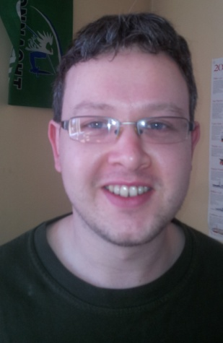

Curriculum Vitae
Linford Woods M.A.

Personal Details

Name: Linford Woods
Date of Birth: 3/2/1987
Nationality: Irish

Educational Details

Postgraduate Study:

2007-2008 Master of Arts in History
National University of Ireland, Galway
1st Class Honours

Undergraduate Study:

2004-2007 Bachelor of Arts in English and History
National University of Ireland, Galway
2:1 Honours Degree

Secondary School:

1999-2004 Leaving Certificate 2004
St. Nathy’s College, Ballaghaderreen, Co. Roscommon
Passed with 450 points and 6 Honours including:
English, Maths, History, Geography, Phys/Chem and Applied Maths

Work Experience

The House Hotel, Lower Merchants Road, Galway
Date: June 2012 – Present

I am currently working in the House Hotel as part of the bar staff there. This job is giving me great experience working in an intense and high-speed environment where good teamwork is a necessity, as well as giving me experience dealing with customers and using a Micros EPOS system. I have really enjoyed working in a customer service based industry as it has allowed me to develop my people-skills.

National University of Ireland, Galway
Date: Part-time from April, 2009 to Present

Title: Invigilator

Since April 2009 I have worked as an Examination Invigilator at all examination session held during that time at NUI Galway. My primary duties include the supervision of students during their examination, and the other various organizational duties involved in handing out papers and scripts, as well as handling necessary paperwork. Furthermore, I have found that this position involves a lot of hands-on interaction with the students, dealing with various problems they might have in a professional but very informal way. Coping with such a variety of issues in an examination hall containing up to 850 students has, I feel, provided me with excellent experience in dealing with people and problems while under pressure, whilst at all times maintaining calm even when students may themselves show signs of panic and stress. I believe this job will certainly have prepared me for a pressure work environment, as well as showing me the value and importance of accuracy regarding paperwork.

Title: Academic Assistant and Tutor

I have also, in my time working for NUI Galway, given tutorials in the History department there. These involve hour long classes where I would teach up to fifteen students at a time. I really enjoyed this role as it allowed me to explore less familiar areas of History and how to develop ideas for teaching various topics. Above all, this work instructed me in how best to interact with students in order to get the best out of them and has, I feel, vastly improved my communication skills.

Desmond Woods Carpentry
Duration: Summer and Part-time work 2000-2009
Title: Assistant

During my summers whilst at school and later at University I assisted my father in his profession; fitting kitchens and wardrobes, both on building sites and in private residences. This work showed me the value of hard graft, the importance of team-work and, above all, about maintaining a standard of quality in my work.

Interests & Skills

- I am computer proficient with Microsoft Word, Excel, and PowerPoint, as well as being very familiar with all Windows-based systems
- I have experience operating a Micros EPOS till system.
- I am a fast and competent typist, with an average of about 60 words per minute.
- I enjoy reading and watching films in my free time.
- I am an avid music fan and enjoy playing the guitar, piano and harmonica.
- I am a passionate rugby fan and I try and express this in my rugby blog whenever I can. I also enjoy playing with my Tag Rugby team.

References

Dr. Caitríona Clear
Senior Lecturer in History
National University of Ireland, Galway
Tel: 091 493099
Email: caitriona.clear@nuigalway.ie

Denise Byrne
Exams Office
National University of Ireland, Galway
Tel: 091 492916
Email: denise.byrne@nuigalway.ie

