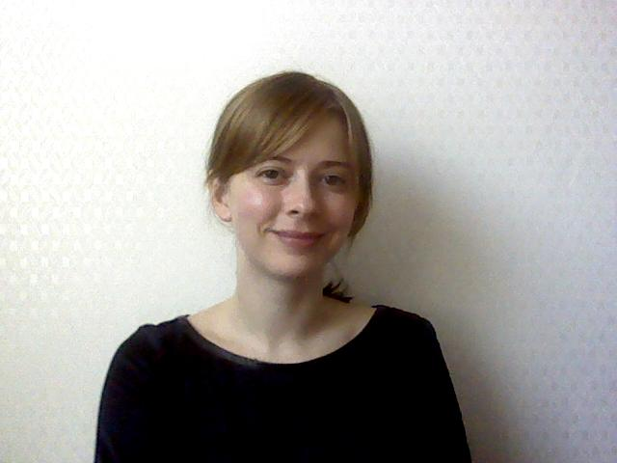

80 Maple Lane, Ottawa, Canada, K1M 1H4 • lsteadm@gmail.com

Laura Steadman

Objective:
To obtain a secure ESL/EFL instructor position that allows me to fully utilize my teaching experience with the possibility to work closely with the schools on helping to develop curriculum, writing materials and ESL workbooks.

Experience:

March 2012 – March 2013 Advanced Junior English Seongnam, Korea
English Teacher / Curriculum Developer
- Responsible for instructing elementary school students.
- Classroom focus on reading comprehension and critical thinking skills and phonics.
- Duties include following a set schedule, classroom management and evaluating the students’ development.
- As a curriculum developer, responsibilities included designing reading comprehension workbooks, literature leveling, phonics curriculum.
- Leader in the designing of new writing curriculum, focusing on diverse writing styles, including basic grammar activities, narratives, brainstorming, and comparatives. Introducing essay writing instruction to students using three to five paragraph essay styles.

Feb. 2011- March 2012 LCI Kids Club Seoul, Korea
English Teacher
- Responsibilities were teaching English to kindergarten and elementary school students.
- Focus on phonics, reading, writing, and reading comprehension.
- Develop weekly themes for the students as well as phonics courses for Kindergarten classes.
- Instructed the students in Science, Art, Library, Gym, as well as Critical Thinking courses.
- Duties included classroom management, student evaluations, creating tests and activities, and maintaining a positive relationship with students and staff.
- Worked closely with Korean partner teachers to adjust curriculum for each student’s needs as well as maintaining excellent relations with the students and the student’s families.

May 2009-January 2011 Trinity English Academy Seoul, Korea
English Teacher
- Duties included teaching reading comprehension, writing skills, grammar, and language to children aged 7 to 13.
- Responsible for classroom management and student evaluation, as well as maintaining professional relationships with parents and staff.

May 2009-January 2011 E-Public Co. Ltd Seoul, Korea
Research and Development
- Responsible for creating English reading comprehension workbooks for Korean students.
- Workbooks included vocabulary activities, reading comprehension and critical thinking questions, and writing activities.
- Edited, reviewed, and leveled workbooks for students and for publication.

Education:
Bachelor of Arts, Concordia University, May 2007
- Classical Civilization Major

Additional Skills:
- Four years of ESl/EFL educating experience.
- MS Office Suite: Word and Excel.
- Typing: 50 WPM
- Language Skills: English and French.
- Problem solving and conflict resolution.
- Curriculum development and workbook building.
- Test and Writing Book preparation.

