Kristen Majkowski

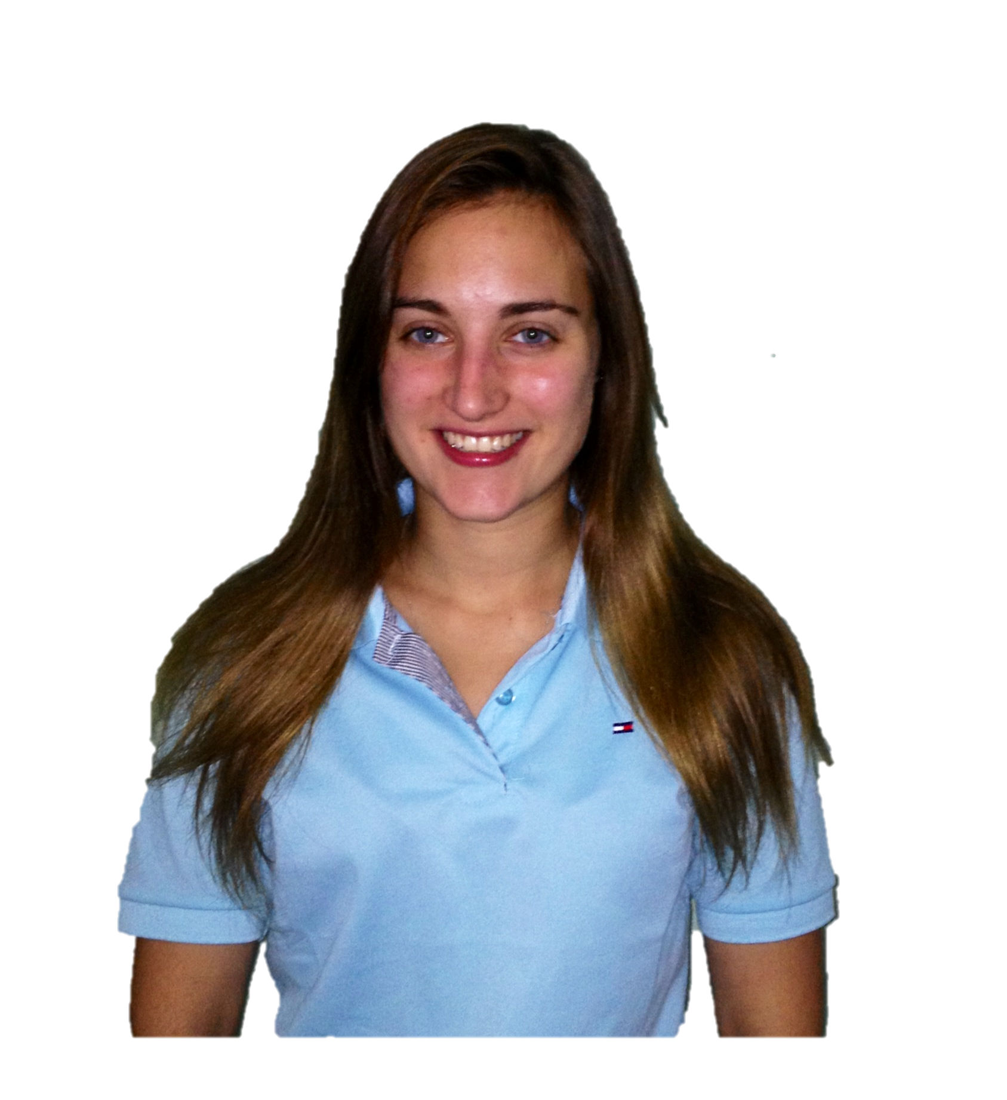
NATIVE ENGLISH SPEAKER
CITIZENSHIP: USA
D.O.B. June 24, 1989
GENDER: Female

EDUCATION: 120- Hour TEFL Certification Completed: 07/12
TEFL Institute, Chicago, IL USA
100 hours of training with 20 hours of student teaching

Ithaca College
Graduated: May 2011 Bachelors of Science
Major: Speech Language Pathology & Audiology
Minor: Deaf Studies

Achievements: Laurence S. Hill and Adrian M. Newens Academic Scholarship in Health Professions, Dean’s List Fall ‘09, Child Language Research Lab Team Member, Varsity Track and Field 07-09, Cross Country 07-09, NSSLHA Club Member, Member of NSSLHA through ASHA (attended ASHA Convention 2010

Personal: Date of Birth: June 24, 1989 Nationality: American

EXPERIENCE:
Teaching
Tianjin Oriental Baby Care, Tianjin, China 02/13- present
ESL teacher for Chinese students ages 3-10.
Created teaching materials and lesson plans for class sizes ranging from 2- 7 students using a broad spectrum of media (eg: Smartboard technology, IMTS player, picture cards and handouts).

Nassau BOCES, East Meadow, NY 07/11- 08/11
Teacher Aide for children with Autism and other disabilities.
One-on-One daily responsibility for a 10 year old Autistic male

Head Start Program, Lansing, NY 01/11-05/11
Clinician for Communication Enhancement Program
Created language development lesson plans weekly for a group of four pre school students considered to be at risk, and monthly “circle time” activities for the class of sixteen students. The year was completed with a Progress Report on my individual student for the semester.

Teaching Child Language Research Lab Project, Ithaca College 08/10 – 05/11
Observation Research project on Defining Neighborhood Density, initial group research included researching articles about Neighborhood Density hoping to develop a more functional definition. Word lists of Neighborhood Density were compiled.

Speech Therapy Observation, Ithaca College, Ithaca, NY 08/10-12/10
The Sir Alexander Ewing- Ithaca College Speech and Hearing Clinic
25 hours of observation of a 7 year old boy with mild childhood apraxia. SOAP notes (Subjective, Objective, Assessment and Plan) were compiled on the session.

Woodland Middle School, East Meadow, NY 04/11 Speech observation of Middle School students in a speech classroom

Queens PS 107 Elementary School, Flushing, NY 01/10
Theraplay, NYC, NY
Observation in a speech classroom and Occupational Therapy room.

Boynton Middle School, Ithaca, New York 01/09-05/01
Observed 50 hours in a Special Education classroom, assisting students with classroom projects and attended mainstream classes with them.

Current Position Syosset Primary Care, Syosset, NY 08/11- 01/13
Receptionist for the office duties include answering phones, entering demographics and coordinating appointments.

Internships SL Green Realty Corp., NY, NY 05/10 - 08/10 Responsibilities Included administrative responsibilities.

Fisher Brothers, NY, NY 05/08 - 08/08
Responsibilities included administrative responsibilities for human resource.

PT Assistant Therapeutic Solutions, Merrick, NY 04/07
Assisted the Physical Therapist in treating patients.

Ithaca College CTS Technician & Mail Services Driver 08/10 – 05/11
Support AV equipment & sorting and transporting mail packages.

