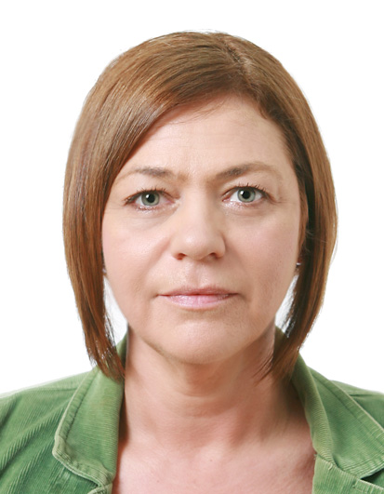

Julie Anne Bennick

Home Address: Current:
4102 E. Marietta Jeonju, South Korea
Decatur, Illinois
United States of America
Nationality: American

Skills
• Effective communication skills, and interpersonal:
As a teacher I had to communicate with people from all social economic levels. Also as a store owner it was needed in order to keep consumers coming back.
• Problem solving:
As a teacher I worked with children that had behavioral problems. I had to solve problems that arose with the children. I have also worked with the mentally challenged.
• Organizational skills:
As an internship I authored, designed and produced an informational class on FAFSA (Federal Student Aid) from a student’s prospective.
• Research and Development:
As an ESL teacher working with adults I had to assess their different learning capabilities. I implemented a test at the beginning of classes to assess their level of English. I did activities, speaking, and reading.

Experience
4 years teaching experience in South Korea.

Topia Jeonju, South Korea
ESL Teacher 10/2012 to 05/2013
Taught English to Korean students ages 8 through 17.
Woosuk University Wanju, South Korea
ESL Teacher 3/2012 to 6/2012
While at Woosauk University I researched and developed adult classes for various companies I taught at. I also taught at junior high and elementary public schools.

Jeongsang Language School Jeonju, South Korea
ESL Teacher 6/2010 to 3/2012
• Taught English to Korean students ages 8 through 13. We discussed story comprehension techniques and implemented writing portfolios. Also I researched and developed my own conversation classes for elementary students.
Topia Jeonju, South Korea
ESL Teacher 08/2009 to 5/2010
• Taught English to Koreans age 8 through adults. I taught phonics and played educational activities. I researched and developed adult classes for the various companies I taught at.
Education

University of Illinois at Springfield Springfield, Illinois USA
B.A. Legal Studies with a minor in African American Studies December 2006

