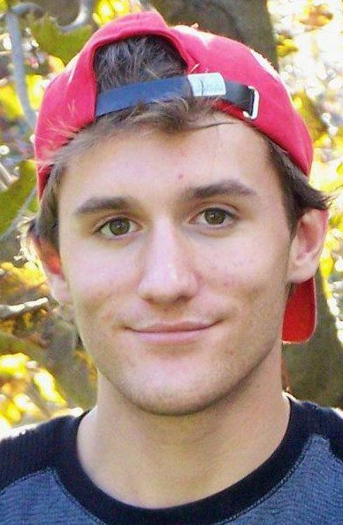
Jesse Farrelly

Objective: To secure a position in which I may employ my skills and positive work ethic to become a vital asset to a company or organization

Qualifications:
  - Excellent organizational and time management abilities
  - Enthusiastic learner with the ability to grasp new tasks quickly
  - Responsible, punctual and incredibly reliable
  - Exceptional academic achievement
  - Able to effectively work in a team or independently
  - Strong social and communication skills

Education:
Wilfrid Laurier University – Honours Degree in Sociology 2009 - 2013

Employment History:
Special Services at Home (SSAH) Worker September 2012 – September 2013
- Provide outlets for individuals to experience new opportunities
- Facilitate activities within the community
Extend-a-Family Summer Program Leader June 2011 - September 2013
  - Work within team to create summer program
  - Facilitate participants with activities
A.O Smith June – September 2009 & April –September 2010
  - Assisted in creation of new water heaters
  - Cleaned up work area after job was completed

Volunteer Experience:
  - Coached youth soccer team
  - Time keeper at Fergus Minor Hockey Tournament
  - Best Buddies Program through Wilfrid Laurier University and Extend-a-Family

Accomplishments:
- CPR Training
- Nonviolent Crisis Intervention Training
- MVP Lacrosse

