Hi Dan
It's my pleasure to work with you.
I'll try to find the sutiable position for you.
I'd appreciate if you advise me of your starting date.
Please let me know when will the visa documents ready(apostilled criminal check, apstilled diploma)
Thank you for your cooperation.
I hope to hear from you shortly.
Have a great day.

Best Regards
Cassie

Hi Dan
It's my pleasure to work with you.
I'll try to find the sutiable position for you.
I'd appreciate if you advise me of your starting date.
Please let me know when will the visa documents ready(apostilled criminal check, apstilled diploma)
Thank you for your cooperation.
I hope to hear from you shortly.
Have a great day.

Best Regards
Cassie
Hasan Tezer

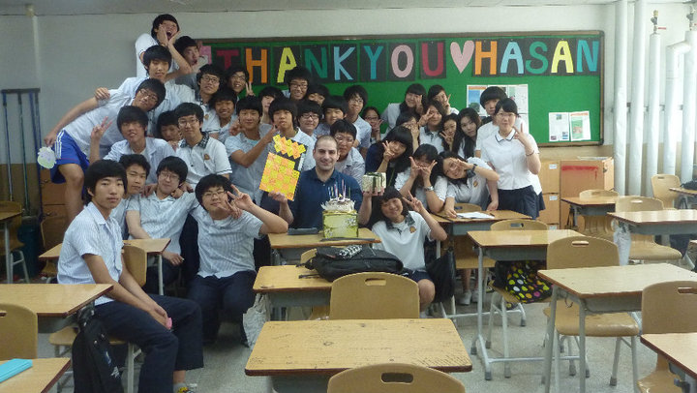

Address: 94 Fox Lane, Palmers Green, London N13 4AX
Phone: 07707749688 Nationality: British Marital Status: Single
E-Mail: Hasantezer@gmail.com Skype: Hasan-Tezer

Qualifications: B.A (hons) Drama and Film, Trinity TESOL certificate

Objective
I’m an experienced and dedicated English teacher looking to build my career in teaching English whilst I study for an MA TESOL through distance study.

Experience: Three years +

Oxford Academy 03/09-07/09 and 1/13 to present day

I teach different nationalities at Oxford Academy. I teach Elementary and Pre-Intermediate level adult students using materials such as New English File. I’m responsible for creating tests for the students and giving them regular homework. I also teach ESOL to young learners covering comprehension, grammar and writing.

GEPIK: Yangmyung High School + Editor for GEPIK. 03/11-09/12

I taught large classes independently at Yangmyung. I was responsible for creating a curriculum for the students to follow and using technology to present lessons. I was able to develop strong Classroom management techniques, as I was the lone teacher in class. I also worked as an editor for textbooks used in middle schools in the Gyeonggi-do region of Korea.

GEPIK: Juyeop High School 08/09-08/10
I worked as an assistant language teacher at a high school in South Korea. I worked alongside a Korean teacher to deliver lessons. I gained key team working skills working with the Korean teacher and ways to keep students motivated and interested in learning English. I was also responsible for teaching English to the staff at Juyeop.

Jungchul Academy 6/08-12/08
I taught students of all ages I started my career teaching English in a rural area of South Korea where I developed my ability to be independent and ability to convey ideas to low level English learners.

Education

Nottingham 2013 - 2015
M.A Tesol

Kingston University 2003-2007
Drama and Film
Bloomsbury International 2009
Trinity TESOL certificate (155 hours 6 observed teaching hours)

Key Skills
Management – managing a room of over 35 students
Organisation – creating daily lesson plans
Communication – communicating ideas to people whose first language is not English
Presentation – presenting to students and to other teachers for ‘open classes’
Adaptable – Lived abroad for over three years
Patience and stress management – thriving in testing environments and capable of being independent
Editing – editing textbooks for middle schools throughout Gyeonggi-do region of Korea.
Team work- Able to work with staff in creating suitable lesson plans

