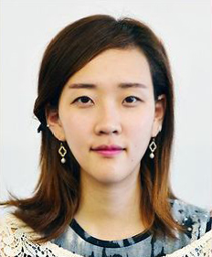
OBJECTIVE
Accomplished, proficient in English and Korean, achievement-driven and skilled
in Language, Art, Music and in working with children, interested in teaching position.
BACKGROUND
Immigrated from Korea to United States at the age of ten and have been educated in the U.S. since. Speak
fluently in English and Korean. Currently a student at SDSU with various experiences that developed leadership,
planning and communication abilities, great people skills that will make great contribution to the workplace.
EDUCATION
San Diego State University, CA | Expected to graduate Fall 2013
Graphic Design Major
Child and Family Development Minor
History Minor
SOFTWARE
- Excel -Quickbook - Photoshop - Powerpoint - Illustrator - InDesign
WORK HISTORY
2002 – Present Keyboardist, Musical Director for Children | Calvary Korean Presbyterian Church
Play the keyboard for the worship team and in charge of creating and leading body worship.
2005 – Present Personal Tutor
Help and teach children and adult in English, Korean, and in writing individually.
2005 (3 Month Intern) Graphic Designer |San Diego Joins (중앙일보)
In charge of designing the magazine for San Diego Korean Community
2006 – Present Kindergarten Director| Calvary Korean Presbyterian Church
Manage and operate kindergarten class and disciple teachers. Teach and develop
programs that will help the children to learn.
2010 – Present Freelance Graphic Designer
Design personal business cards, posters and Logos for individuals or companies. Design
and publish local magazine and brochures.
2011 (2 Month Intern) Graphic Designer |SD Best Sign
Responsible for designing signs, logos, posters and flyers.
2011 – 2012 Accountant Assistant | Bluestone Lodging, LLC
In head of Controlling, managing and checking the cash flow of the three hotels that
were operated by Bluestone Lodging.

