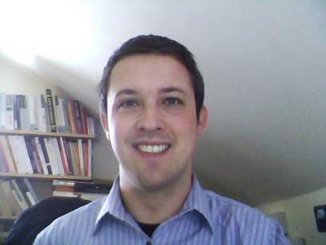

Gareth Kevin Holvey (Date of Birth 29/11/1987)
Address (UK): 26 Stonebridge Road
Rassau, Ebbw Vale, Blaenau Gwent
NP23 5SN, Wales, U.K
Telephone Number (UK): +4401495301755
Number to call to obtain Korean reference: 010-5880-0925
Email: garethh87@gmail.com
Educational Background
September 2006 to August 2009 – Graduated with a B.A (2:1, roughly equivalent to a 3.4 GPA in the USA) in English at Swansea University.
October 2010 to September 2011 – Graduated with a MA in English from Swansea University
English Language Teaching Certification
Certificate in Teaching English as a Foreign Language from TEFL Wales (20 Hour Classroom TEFL Training and 80 Hour Online TEFL Training)

Professional Experience
2006 - 2009 – Performed various duties at university such as representing the English department to potential students. Tasks included taking tours of the campus, informing prospective students of the department’s syllabus/curriculum.
2009 - Feb 2012 I have undertaken various informal tutoring and proofreading assignments that utilise my skills that I have learnt during my time at university. Exam preparation with an emphasis on English language and literature is a prominent feature of my tutoring.
Feb 2012 – Feb 2013 I was a native teacher at Bupyeong ECC from February 2012 to February 2013. I had been given the opportunity to extend but I want to look for new challenges elsewhere in Korea.

Other Skills
Proficiency at using Microsoft Word, Powerpoint and Excel.

Hobbies and Personal Interests
A deep interest in foreign cultures, particularly literature and cinema not in the English language.
Literature and poetry in general.
Playing the bass guitar.

