EMMALYN ROSELL KIM
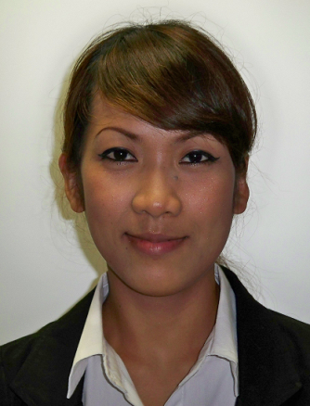
서울시 금천구 독산동 3동 979-29
F-2 Visa
Cell; # 010-9227-0205
Phone: 070-7621-0205
Email address: iyah_rosell@yahoo.com

CAREER OBJECTIVE
To obtain a English Teaching Position with your Organization

SKILLS:
- Have taught English as a Second Language for 3 years
- Familiar with educational teaching approaches
- Capable of classroom management
- Knowledge in curriculum development
- Experience in early childhood teaching

EDUCATIONAL EXPERIENCE:
- University of Perpetual Help DALTA (B.A Degree) Undergraduate degree in Hotel and Restaurant Management March 2006 Las Pinas City, Metro Manila.

- High School: Bukidnon National High School of Home Industries March 2002
San Andres School

- Elementary: Mascarinas Elementary School March 1998

WORK EXPERIENCE

Heabub English Academy March 2007-February 2008
Seoul
Will English Academy April 2008-January 2009
Seoul
.
Dongsim Publishing Company March 2009-february 2010
Incheon

Witney English Reading Academy (2009-2010)
Sungpa-gu Jamsil Seoul korea.
[kbs위기 탈출 넘버원 , mbc서프라이스 등 출연, CF 인천일보 경인 지역 방송]
인천지역 영어 마을 아르바이트

TRAINING AND SEMINARS ATTENDED

Incheon Women Hotline (certificate)
Strategies of Teaching English in Korea
Incheon Korea. December- February

PPCWC Academy
Pupyeong Community Welfare Center
Korean Language Class
Bupyeong, Incheon (certificate)

Kotesol International Conference
April 2009

SKILLS

Bilingual English and Korean (High-Intermediate Level)
Computer Literate/Dancing/ Modeling/Acting

REFERENCE:

Darrell Monkman (Professor Of English)
Kyung Hee Cyber University
American Studies Dept.
Cell: 010-7799-4035
Email: darrellmonkman@gmail.com

