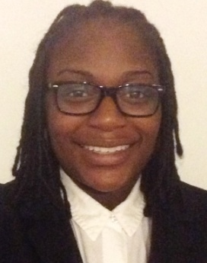

DONISHA YOUNG

EDUCATION
Bachelor of Business Administration | Major: Marketing  St. Francis Xavier University, Antigonish, NS  September 2010-May 2013
Diploma | Focus: Marketing  Sheridan College, I.T, Brampton, ON  September 2008-April 2010
PROFESSIONAL EXPERIENCE
Sales Consultant | An expert in all areas of product knowledge, met and exceeded monthly sales targets, exceeded customers' expectations by going the extra mile, demonstrated initiative in learning and understanding new products, services and promotional offerings.  Bell Canada, Brampton, ON  June 2012-September 2012
Sales Associate | Responsible for providing excellent customer service in a retail environment, followed company sales programs and targets, maintained and achieved productivity goals and provided great customer service.  Foot Locker, Brampton, ON  September 2007-September 2011
Marketing Coordinator | Assisted the marketing team with various tasks such as customer satisfaction analysis, product development and service programs, delivered marketing information in a timely manner on behalf of the marketing department.  Sheridan Student Union, Brampton, ON  September 2009-May 2010
Camp Counselor | Taught basic to advanced basketball skills including: ball handling, drills, plays and strategies, coached scrimmages and games.  Sheridan Bruin Basketball Academy, Brampton, ON  July 2009
Camp Counselor | Taught basic to advanced basketball skills including: ball handling, drills, plays and strategies, coached scrimmages and games.  Shane Bascoe Basketball Camp, Brampton, ON  July 2008
ADDITIONAL QUALIFICATIONS

- Valid G License
- Demonstrates teamwork and leadership abilities
- Self-motivated, organized, and detail oriented
- Excellent interpersonal and communication skills including reading, writing and fluent English
- P.C skills: MS-Word, Excel, Power Point and Social Media
- Passport to Safety Challenge certificate

