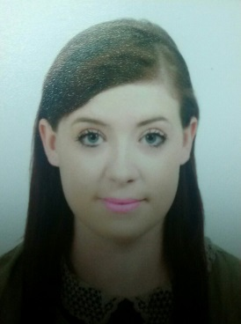 Denise Doyle
Sadang Dong,
South Korea

29/10/1989

Qualifications and Education

Post Primary Education
Our Lady of Lourdes Rosbercon, New Ross, Co.Wexford 2002-To 2007

Third level education
- St .Patrick’s College, Pontifical University, Maynooth, County Kildare.B.ATH degree in theology and anthropology .Course duration three years. 2007-2010
- St .Patrick’s College, Pontifical University, Maynnoth, Co.Kildare.Postgraduate Diploma in Christian Communication and Development .Course Duration One Year. 2010-2011
- TEFL 140 Certificate

Relevant Experience

January 18th -22nd 2011
KCI 102.5 FM, Kairos Communications .Live radio broadcast as part of Postgraduate Diploma in Christian Communication and Development. Duties included conducting research, producing live one hour drive time slot, a half an hour arts programmed and conducting numerous interviews.

March 2013
Slaney Language School, Ferrycarraig, Wexford. Gained observation work with Elementary, intermediate and upper intermediate levels. Assisted the teachers at the school with group activities for mixed abilities and helped students with their work throughout the day. Observed classes throughout the day. 053) 912 0881

July 2013-to July 2014- English academy,Pyeoungchon, South Korea. In this teaching position, I have taught varied levels ranging from kindergarten to middle school. I have also taught a university student at my school for the duration of my contract. I have conducted interviews with potential students and assessed their level .I also am experienced at lesson planning and book ordering.
March 2015- Present
.After school teaching position –Teaching grades 1-5.Skilled in lesson planning .Preforming open class twice a year to great reviews.

References Available Upon Request

