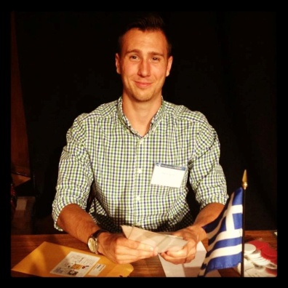

David Heflin

668 4th St | (951) 212-8320
San Jose, CA 95112 | David.heflin@sosharu.co
Linkedin Profile | www.linkedin.com/in/davidheflin/

Education

BA Economics San Jose State University – 2010 to May 2013
Riverside Community College – 2008 to 2010
Skills

- Public Speaking
- Microsoft Excel
- Microsoft Office
- Power Point
Work Experience

Aug 2012 to Present
Sosharu, San Jose, CA
Founder

- Founded a company that helps small businesses strengthen relationships with customers and
promote themselves through social media. Primary responsibilities include business development, writing
monthly client reports, integrating clients website with social channels, billing and support, and designing
advertising campaigns.

Sept 2012 to Nov 2012
ZenDeals, Palo Alto, CA
Social Media Intern

- Created a PowerPoint presentation for future interns with instructions on how to develop and implement successful online campaigns. Implemented strategies to grow the company’s online community. Wrote bi-weekly online community. Developed and launched company's first paid advertising campaign.
May 2012 to Aug 2012
I Am San Jose, San Jose, CA
Social Media Intern

- Initially recruited to help volunteer at events, I effectively communicated social marketing strategies
that would empower the organization and help foster relationships with their community. Launched
organizations first Twitter profile, Facebook Page, and Instagram account.
Activities
Feb 2012 to Present
Economics Club at San Jose State University, San Jose, CA
Social Media and Community Manager

- Provide an engaging online community for club members and faculty within the economics department. Attract new members to events by developing captivating content. Maintain and update blog.
Feb 2011 to May 2011
Alpha Kappa Psi at San Jose State University , San Jose, CA
Mu Pledge Class President

- Led a team of 12 students to become members of the main organization by completing several challenges. Created multiple fundraising projects that raised over $500. Gave multiple speeches introducing new class ideas to ruling student body and educated members on upcoming events.

