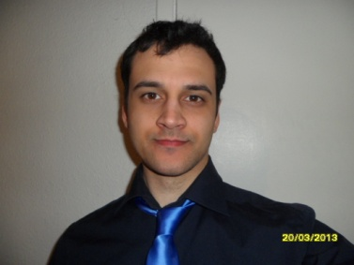

Daniel Olson
70 Pooleys Lane
Welham Green
Hertfordshire
United Kingdom
AL9 7LF
Tel: +44 01707 886822 Mob: +44 07834175970

Creative and motivated individual who enjoys learning new skills and always improving them.
Relaxed and friendly person that gets along well with others.
Imaginative writer that has produced published game reviews and fiction.

Education

Jan 2013 120 hour TESOL Course
To
Present

Sep 2008 De Montfort University
to Leicester
Sep 2012 BsC Computer Games Programming

Modules include:
Creative Client Computing which involved creating online media and websites.
Database Design and Implementation using SQL.
Programming in C/C++ and Java for Mobile Phones.

Sep 2006 Oaklands College
to Welwyn Garden City
Sep 2008 BTEC National Diploma for IT Practitioners

Modules included:
Communication Technologies.
Website Production and Management.
E-Commerce.

Work History

Jul 2011 Runner
to BenjiPhotography
Sep 2011 Hertfordshire

Setting up media equipment for shooting music videos.
Preparing props, makeup and food for the cast and crew.
Maintaining high energy levels to keep cast and crew uplifted from early morning starts to late night finishes.
Retrieving any additional items needed.

Sep 2006 Professional Gamer
To
Sep 2007

For roughly a year I played with a sponsored team and was paid to travel across Europe to compete at events. Our team had some good success and competed in the biggest tournaments such as World Cyber Games and Cyberathletic Professional League.
I improved my dedication and communication with my team mates who came from all over the world.

Interests

Playing video games which led to professionally playing them in a sponsored, world-wide team
Writing sci-fi and fantasy fiction
Playing the shakuhachi and ukulele
Studying new languages
Mixed-Martial arts

