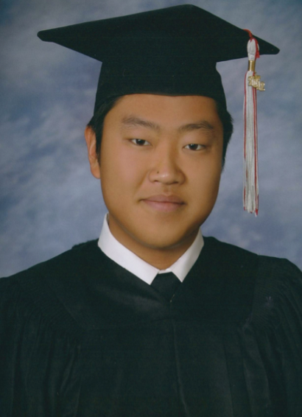
Chris In
4417 El Corazon Ct.. Camarillo, California 93012
Phone: (805)415-2756 . E-Mail: chris.in345@gmail.com

Objective
My objective is to find full-time employment teaching English in South Korea.

Experience
United Water Conservation District 01/08-10/12
Part-time seasonal employment as a fisheries biologist technician. Worked on various projects involving
federally endangered steelhead trout throughout the Santa Clara River watershed.
Grade Potential 09/08-present
Part-time employment as a science and math tutor for students K-12 as well as college students.
Sushi Fresh 01/13-present
Part-time employment as a sushi chef at a high paced Japanese restaurant.

Education
Adolfo Camarillo High School 09/03-06/07
High School Diploma
California State University Channel Islands 08/07-05/12
B.S. Biology (emphasis Ecology, Evolution & Population Biology)
Ventura County Community College District 09/12-present
A.A. Music Education

Skills
With an affable, upbeat personality and a drive to get things done, I am a young recent college graduate
seeking full-time employment. A hard worker, I understand that completing the task at hand in the most
efficient manner is paramount; equally important is the ability to get along with co-workers and to strive for the
most professional performance possible.
As a science major, I am able to communicate well with others and conflicts that may arise in a pragmatic
manner. I have a lot to prove to future employers. I seek to put dedication and diligence into action.

