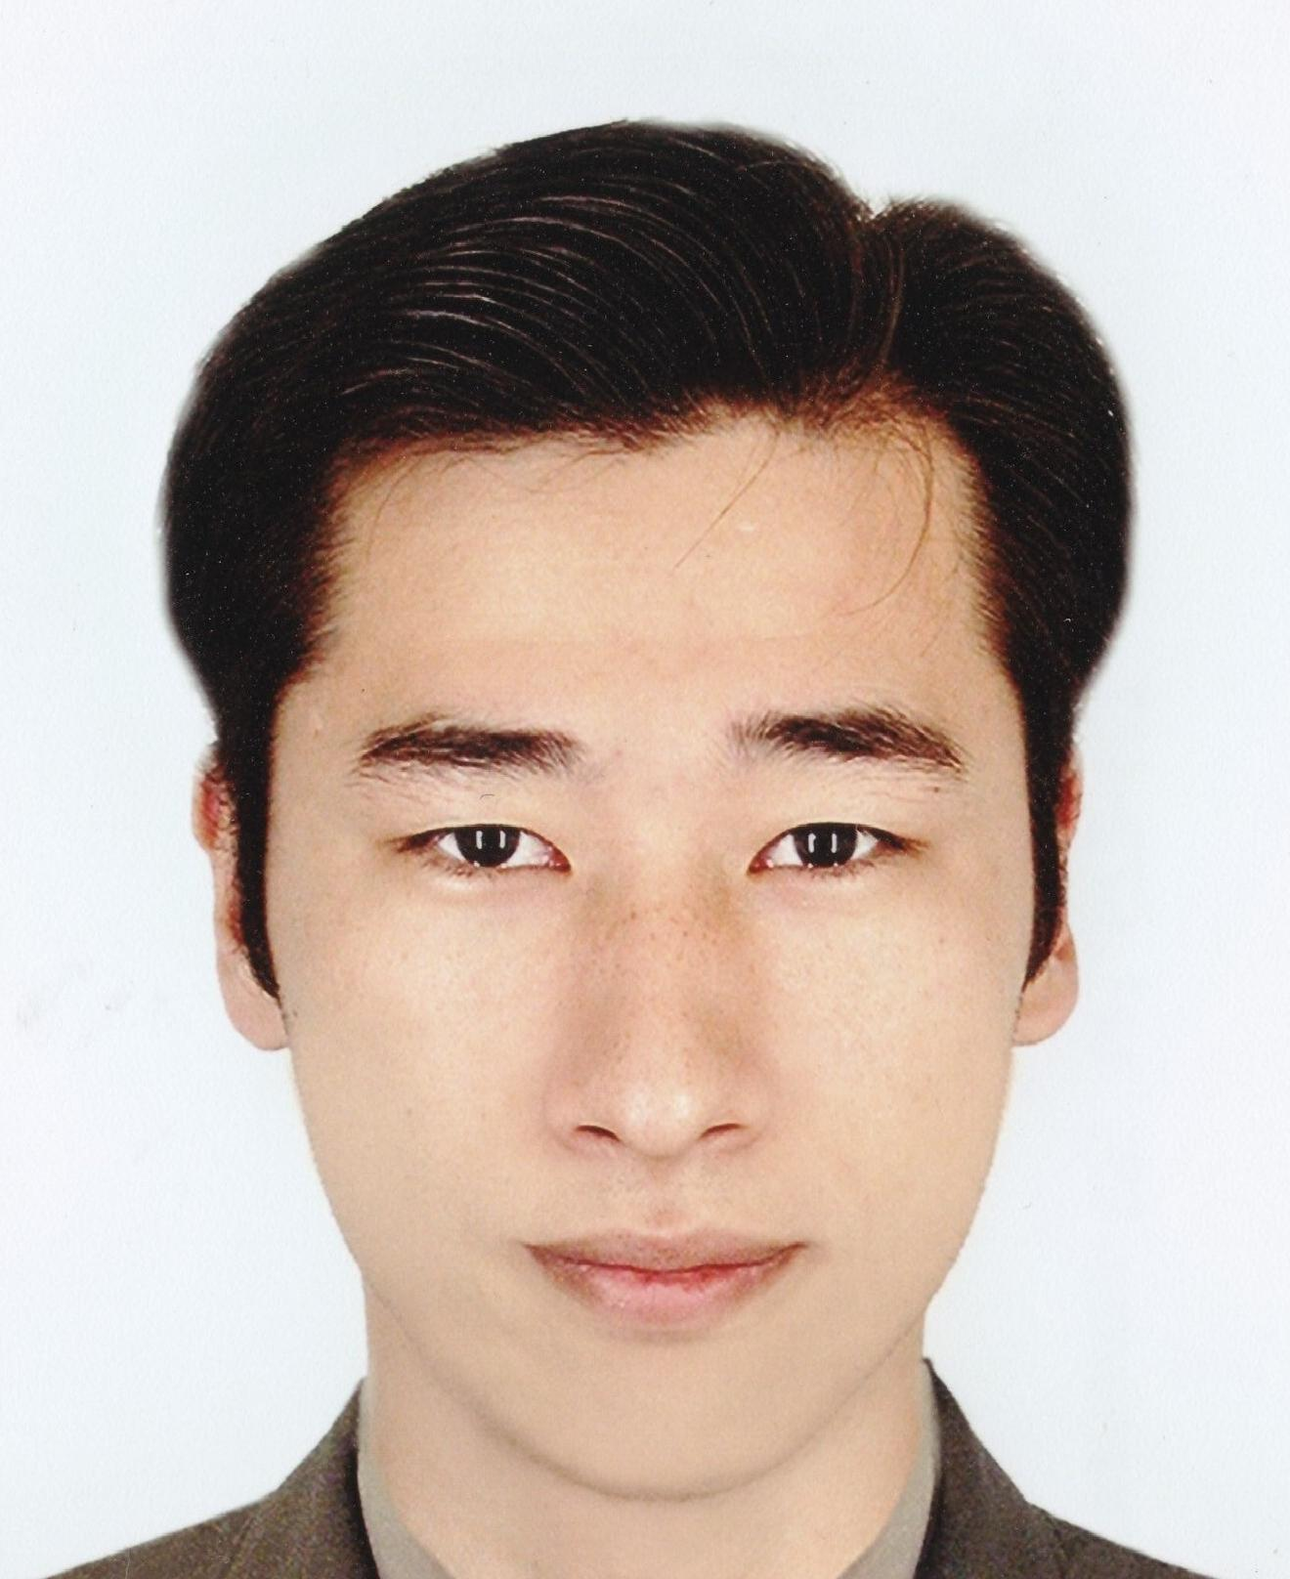Vokhmyanin Sergey
Personal data date of birth: October 4th, 1982
Place of birth: Temirtau town, Kazakhstan
Nationality: Korean
Citizenship: Kazakhstan
Family status: married
E-mail: voksergej@gmail.com

Abilities and skills Professional knowledge & skills of outdoor advertising production;
Sales planning and execution;
Marketing management knowledge;
Accounting of ATL/BTL activities and events;
Organization of staff learning courses
Physical culture trainer;
Personal gym instructor.
Education
2008-2010 y. – International Academy of Business.
Specialty: «Marketing». Bachelor degree.

2000-2004 y. – Kazakh Academy of Sports and Tourism.
Specialty: «Sport Shooting». Bachelor degree (excellent).

Job Experience
From 04.2009 Advertising agency «Gifts&Gadgets».
Position: Director
Responsibilities:
- Negotiations with top-managers of companies-clients;
- Coordination of working of sales and service departments;
- Organization and holding of trainings for staff;
- Controlling high-quality execution of the orders;
- Implementation of mutual in company;
Achievements:
- Constant working realization, stable work value;
- Long-terms deals with clients and suppliers of advertising;
- Perfect sales skills of company staff.

04/2008-03/2009 – advertising manufacturing company “ReArt”.
Position: Executive director. Staff consist of 8 persons.
- Recruiting and selection of specialists for manufacture-shops;
- Controlling and implementation of material purchasing;
- Cost optimization;
- Accounting of large orders;
- Analyze of marketing information about competitors;
- Planning of company activities in short and long terms;
- Brand-management.

Achievements:
- Increased profitability of the company;
- Increased clients loyalty and trusting our company;
- Got good reputation of company as “always in time” partner!

11/2007-04/2008 – Full-cycle advertising agency “New Line Advertising”
Position: Manager of sales.
- Coordination of department activities according to the regulations;
- Promotion and providing of agency’s services and goods;
- Creating of data bases of clients and suppliers of advertising;
- Searching of potential clients;
- Presentation of company, goods and services for new clients.

01/2001-11/2008 - Direction of State National Teams.
Position: Sportsman-instructor. Sport shooting.
Achievements:
- Silver medalist of World Universiade 2007, Bangkok;
- Bronze medalist of Asian Games 2006, Doha;
- Double silver medalist of South-East Asian Championship 2004, Bangkok;
- World Champion 2002 (team), Lahti;
- Silver medalist of World Championship 2002 (team), Lahti;
- Bronze medalist of World Championship 2002, Lahti;
- Multiple winner and medalist of international tournaments and competitions;
- Multiple Champion of Republic of Kazakhstan.

08/2004-05/2005 - Gym «GymFlex».
From 01/2009 Position: Personal gym instructor.
- Compilation diet and program sessions according to the wishes and functional abilities of a client;
- Constant controlling of physical and psychological conditions of client .
Дополнительная информация
PC: MS Office, Internet, - advanced user.
Languages: Russian – perfect speech and written,
English – fluent speech, grammatically right written.
Driver’s license: «В».
Passport: F4 visa.

