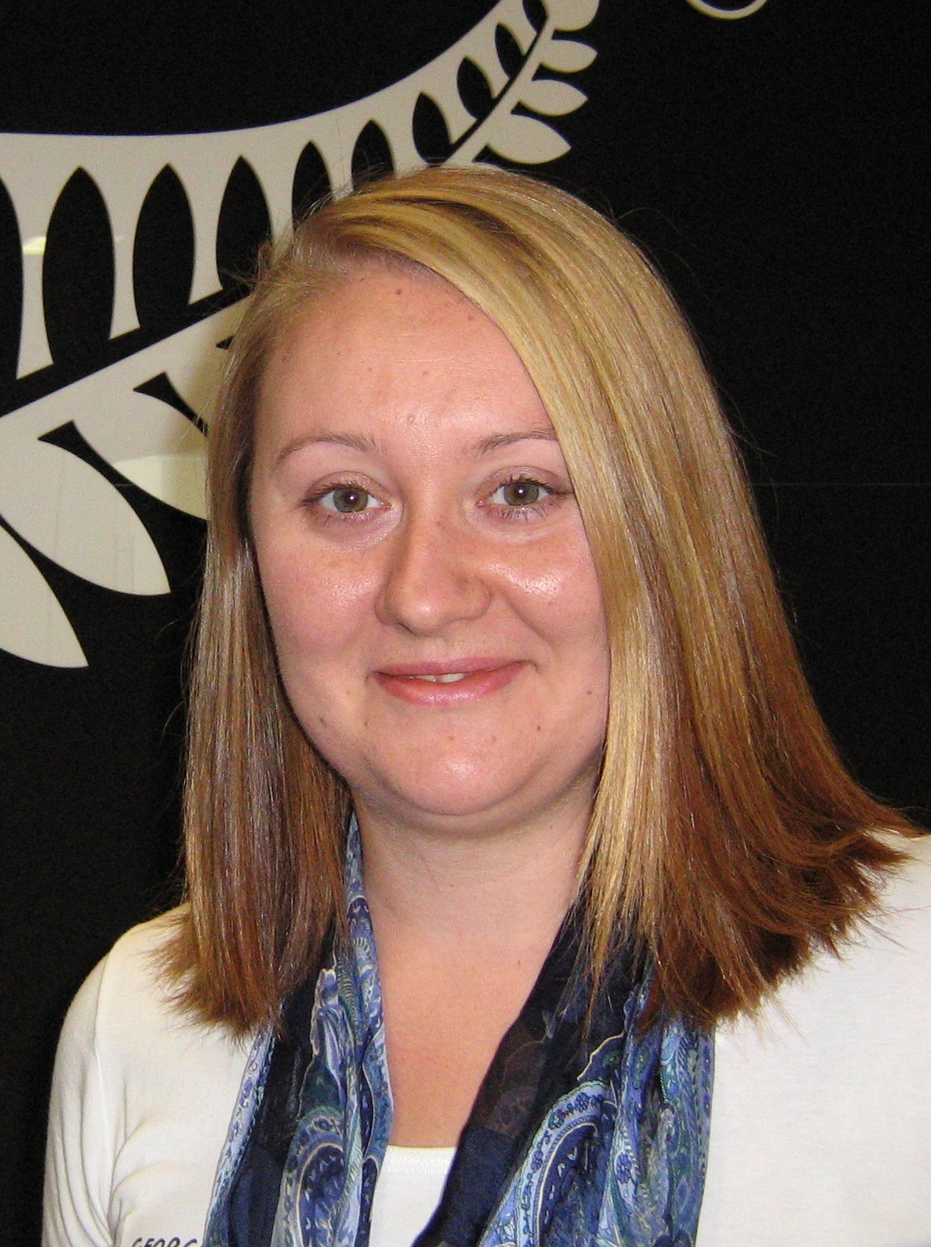Georgina Guscott
georginaguscott@yahoo.com
021 182 8724
D.O.B: 20 September 1980
Nationality: New Zealand
Bachelor of Arts, English Literature

EMPLOYMENT HISTORY

Executive Assistant to Group General Manager/Team Support - Temp Role
Feb 2009 – May 2009
New Zealand Trade & Enterprise, Majestic Centre, 100 Willis St, Wellington
- Providing support to the Education Sector Team including:
  - Issuing invoices and disbursements
  - Organising travel, meetings and calendars
  - Providing support with financials
  - Management of approvals process
  - Project administration and support
- Providing EA support to Group General Manager including:
  - High level calendar management
  - Issuance of financial reports, including variance
  - Collation of sensitive papers
  - Travel and workshop organisation
  - Providing project support to wider team
- Use of MS office suite, JD Edward financial systems, Citrix, Pivotal Client management system, One World, Adobe editing, CardScan

Administrative Assistant – Temp Role
Nov 2008 – Dec 2008
IHC, L15 Willbank House, Willis St, Wellington
- Support of six mangers and Administration Team Leader
- Use of Vista and Office 2007

Professional Development Coordinator – Temp Role
Aug 2008 – Oct 2008
NZICA, Cigna House, Mercer St, Wellington
- Organisation of PD Courses for NZICA members including:
  - Sourcing presenters
  - Arranging venues
  - Overseeing events
  - Collating feedback
  - High member contact

Office Administrator
Oct 2007 – Aug 2008
ATL Systems LTD, L5 Grand Annexe, 84 Boulcott St, Wellington
- Administrative and sales support to Manager and senior salesmen
- Maintenance of office processes
- Organisation of customer functions
- Use of MS Office Professional computer package including Word, Excel, Publisher and Visio including a course in Basic Excel with Ace training
- Purchasing officer
- First point of contact for high priority customers
- Use of CBA finance system
- Preparation of quotes to customers
- Assistance in preparation of RFI responses
- Issuance of invoices

Executive Assistant to General Manager – Temp Role
Jan 2007 – Oct 2007
Health Intelligence Ltd, Ewart Hospital, 2a Coromandel St, Newtown, Wellington
- Administrative support
- Organisation and collation of HR processes
- Calendar management using MS Outlook
- Ordering of stationery, building repairs, general supplies, work orders etc
- Meeting, workshop and conference organisation
- Maintenance of office processes
- Minuting and collation of monthly documents for Board of Directors
- Travel bookings
- Organisation of catering and staff functions
- Use of MS Office Professional including Word, Excel, Publisher and Visio
- Use of Citrix

Administration Secretary/Receptionist – Temp Role
Dec 2006
NZEI, 178-182 Willis Street, Wellington
- General reception duties
- Travel bookings using ‘Business Direct’
- Use of MS Office Professional computer package
- Mail-out preparation
- Personal assistant duties to four executives
- Meeting minute preparation

Head Housekeeper/Front of House/Waitress/Barwoman/Receptionist
Jun 2006 – Jul 2006
Gabriel Court Hotel, Stoke Hill, Stoke Gabriel, Devon TQ9 6SF, UK
- Supervision of all cleaning activities throughout the hotel
- Training of all housekeeping staff
- Re-ordering of supplies
- Greeting and seating guests
- Customer service
- Bar and restaurant duties, including serving drinks, cleaning and dealing with payment
- Checking, re-stocking and re-ordering dry goods for the restaurant and beverages in the bar
- Welcoming guests
- Taking reservations and answering customer inquiries
- Handling check-ins and check-outs
- Use of Active Hotels computer package
- Frequently 2IC to the manger

Lead Operator
Dec 2005 – May 2006
Mammoth Mountain Ski Area, Canyon Lift Crew, Mammoth Lakes, California 93546, USA
- Supervision and training of crews of up to six members
- Management and maintenance of on-ramps, off-ramps and funnel areas
- Delegation of tasks, including ticket checking and chairlift operation
- Customer Service
- Crowd Control

General Assistant
May 2005 – Oct 2005
Duart Castle, Lochdon, Isle of Mull, Argyll, Scotland, UK
- Customer service in the castle, tearoom, and gift shop
- Cash handling
- Baking for the tearoom
- Guiding visitors in the castle and introducing them to clan history

English Language Teacher
Feb 2004 – Feb 2005
Herald School, Kwansangbokhabchungsa, Shinnae-dong, Jungnang-gu, Seoul, Korea
- Teaching classes of up to fifteen students, from kindergarten to high school level
- Event preparation and organisation

English Language Teacher/Curriculum Leader
Oct 2002 – Sept 2003
ASK International School, Mido Sang Ga, Daechi Dong, Gangnam Gu, Seoul, Korea
- Teaching classes of up to fifteen students, from elementary to middle school level
- Responsibility for student placement in the “Pioneer Program”
- Organisation and selection of textbooks
- Authorship of exams and curriculum plans

EDUCATION

1998 – 2000 Tertiary: Victoria University of Wellington - Bachelor of Arts
Major: English Literature, Minor: Psychology
1993 – 1997 Secondary: Wairarapa College, Masterton
1985 – 1992 Primary/Intermediate: Martinborough School

VOLUNTEER/CHARITY WORK

Regular Platelet Donor and Volunteer - NZ Blood Service
Volunteer Labourer - Habitat for Humanity: Berhampore Restoration Project
Coordinator/Group Leader - Ewha Women’s University English Club, Seoul, Korea

REFEREES

Richard Vernon
Senior Salesman
Maclean Computing
L5 Grand Annexe
84 Boulcott St, Wellington
P: 021 491 234
E: richardv@maclean.co.nz

Pat McShane
(Former) General Manager
Health Intelligence Ltd
P: 027 562 8993

Sir Lachlan & Lady Mary McLean, Baronet
Chief of the Clan McLean
Duart Castle
Isle of Mull, Scotland
P: +44 1680 812 309
P: +44 1577 830 311

