March 18th, 2009
★♥♣♠Brian S.W Kim♠♥♣★
Date of Birth: August 5th, 1954

Permanent Address
# 460, Munrae-dong, Young deung po-ku, Seoul, R.O.K

Present Address
202-ho, 232-2, Hyosung 1-dong, Kyeyang-ku, Incheon, R.O.K

Career Objective
To obtain a challenging position that will allow for growth and a chance to use and contribute my education and job experience

Experience

October, 2002 – July, 2008 Kim’s Research CEO

Established a research company called Kim’s Research and assisted Kim & Chang, one of the biggest Law firms in Korea by conducting investigation of trade marks and their markets when required

May, 1990 – August, 2001 ifpi Korea General Manager

Worked to protect the music industry’s rights by covering a number of areas, including;

. Anti-piracy enforcement
. Providing information of the music market situation as well as its investigation
. Promoting national legislation and international conventions

August, 1985 – December, 1990 Pop Music Journalist

Contributed articles on pop music to weekly and monthly magazines such as “TV Guide” and “Music World”

March, 1983 – July, 1985 Oasis Records WEA Label Manager

Assisted regional director by selecting new album releases

May, 1978 – February, 1983 English Teacher and Instructor

Lectured English Grammar and Conversation to students

Education

March, 1973 – February, 1980 So Gang University
Majored in English literature
March, 1975 – December, 1977 Military Service
Worked for the Army

Language Fluent in English (Spoken as well as Written)

Reference Available upon request

I hereby clarify that the above statement is correct and true, according to my past career and experience.

Sincerely yours
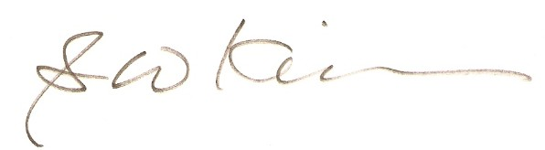
___________
Brian S.W Kim (金 世 元)

☎ Contact : Mobile: 011-342-2542 e-mail brianswkim0@gmail.com
swkim1954@ymail.com
brianswkim0@hotmail.com

