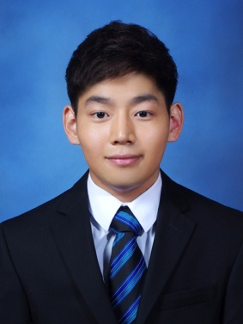

Sung Yup Benny Han
010-5420-5910
shan12@binghamton.edu

Personal Information
Gender: Male
Date of Birth: 09 October 1991
Nationality: South Korea
Work Permit: F-2 Visa
Country of Citizenship: United States

Education
The State University of Binghamton, Binghamton NY
Bachelor of Science in Biochemistry (B.S.), 2013
- Courses in Chemistry, Biology, Physics, and Anthropology
- Courses in Math: Calculus
Skills
Fluent in English and Korean: Resided in the United States for 11 years
Career Experiences
Best Prep Academy- English Tutor: June- September 2009, June-September 2010
English tutor for intellectually disabled child: May- September 2010
SAT tutor at Golden Key Academy: June- September 2011
Hospital Volunteer; May- August 2011, May- August 2012
- Office Job
- Translator for Korean patients
Private Chemistry tutor: October-December 2012
Interned under Plastic Surgeon, Dr. Otterburn: May-August 2012
Extra-Curricular Activities and Interests
Enrolled in Medical Interpreting Program

