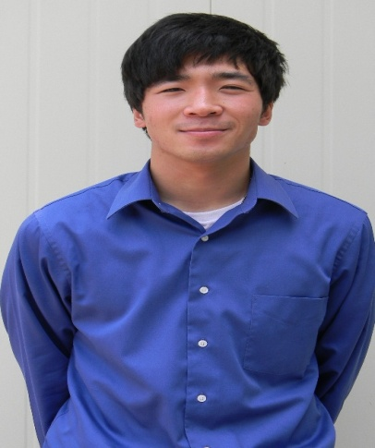

BENJAMIN PAUL COZ

Education

Bachelor’s of Science, Social Work Major Graduated: May 2011
University of Wisconsin-Superior - Superior, WI GPA: 3.805/4.0

University of Yonsei - Wonju, South Korea February 2009 to June 2009

Study Abroad Experience

12 credits completed

University of Minnesota-Duluth - Duluth, MN May 2008

43 credits completed

Teaching Experience

Native English Teacher August 2011-August 2012

Jucheon Elementary School & Mureung Elementary School Jucheon, South Korea
- Designed English speaking, reading and writing activities related to book material
- Instructed 40 minute English Classes grades 3 to 6 five days a week (class sizes 1-24 students)
- Designed after school English Class curriculum
- Instructed 50 minute low, middle and high level after school English Classes ranging from kindergarten to 6th grade four days a week (class sizes 2-20 students)
- Designed and taught an after school Hip Hop class focused on youth empowerment through

B-boying (breakdancing) (class size 12 students)

Dance Instructor November 2010-August 2011

Damiano Center Kid’s Café Program Duluth, MN
- Taught B-boy (breakdance) curriculum associated with life themes to children of varying ages 10-17 from at-risk backgrounds for SO W 480 Research Project Social Work class

English Teacher February 2009-June 2009

Hung Op Elementary School Wonju, South Korea
- Prepared English teaching curriculum and taught to a third grade class of 30 students for an hour once a week

Wonju Children’s Center
- Prepared English teaching curriculum and taught to children ranging from ages 8-13 in a class of around 10 students for an hour once a week

Co-founder February 2008- August 2011
Funk Soul Patrol (FSP) – UMD Student Organization Duluth, MN/Superior, WI
- Led of an organization centered on spreading positive Hip Hop culture through dance in the Duluth/Superior area
- Teaches and mentors all new members in B-boy (breakdance) fundamentals and Hip Hop history and philosophy
- Performed at numerous community and campus cultural events.
- Helped coordinate an annual benefit fundraiser show for an organization that helps victims of sexual assault, an organization that helps with at-risk youth and a nonprofit organization providing affordable performing arts in the community.

BENJAMIN PAUL COZ

Human Services/Social Work Experience

Personal Care Attendant June 2007- August 2011
Arc Northland – Duluth, MN Duluth, MN
- Provided direct one on one care for two selected clients with disabilities including monitoring behavior, integrating into the community and providing respite care for their families
Intern June 2010- September 2010
St. Louis County Child Protection Services Duluth, MN
- Attended meetings and court hearings regarding clients
- Accompanied different social workers in maintaining professional working relationships with 6 different families
- Assessed family safety for children in child protection cases
- Wrote client social health and history reports, drove clients to and from locations and filed paperwork

Peace Circle Co-Facilitator September 2008-August 2009

Men as Peacemakers Duluth, MN
- Underwent the restorative justice peace circle paradigm training program
- Co-facilitated peace circles involving at risk youth and youth who had shoplifted

Sexual Assault Victim Advocate October 2007
Program to Aid Victims of Sexual Assault (PAVSA) Duluth, MN
- Underwent the sexual assault victim advocacy training program

Activities

Public Relations September 2010-May 2011
UWS Asian American Student Association (AASA) Superior, WI
- Promoted AASA on social media, on UWS campus and through personal and professional connections to other campuses

UWS Social Work Program Representative March 2010
Baccalaureate Social Work Program Directors (BPD) Atlanta, GA
Attended the National BPD Conference in Atlanta, GA as a representative of the UWS social work program

Freshman Representative September 2007-December 2007
UMD Asian Pacific American Association (APAA) Duluth, MN
- Represented freshman APAA body, attended general meetings and helped with cultural events

Skills

- Fluent and Native speaker of English
- Able to play the guitar

