Curriculum Vitae

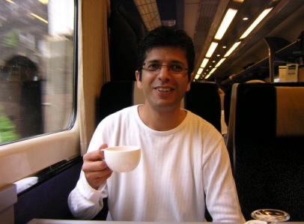
Atif Ellahi Daheri

Address: 1506 Ho 101 Dong
Galsan Jugong 1 Danji Apt
Bupyeong Gu , Galsan Dong 359
Incheon, South Korea
Tel: 010-2643 3813, 070-8202-2301
Email: atifdaheri@ymail.com

PERSONAL STATEMENT

In excellent health, I am a person in my late 30’s highly motivated, hardworking and adaptable. With wide and varied job skills, I am proactive by nature and well used to operating under pressure.
And am committed to both employer and customer satisfaction. I am flexible by nature and willing and able to work such hours as are necessary to fulfill my work and other responsibilities. As an efficient and organized person, who is equally able to work in a team environment or on my own initiative, I believe that I would be an asset to any employer. To work in an organization where opportunities are available to prove my mettle,
Responsibilities are challenging and chances to rise are plentiful Whilst in Africa, I developed a good rapport with students, individual and group alike. I am very personable, punctual and I like meeting new people. All of these attributes helped me in Africa and I believe that they will help me be a good teacher in Korea, too.

EDUCATION

09/00 | Harrow College, London, U.K | Windows Microsoft Office 2000
09/94  09/92 | Sindh University, Pakistan  Sindh University, Pakistan | Degree. BA Arts  Intermediate English and Maths.
09/88 | Cambridge School, By Drizen Titurial College,  London, U.K | GCSE’s including English and Maths.
09/84 | Drizen Titurial College,  London, U.K | Studied 5th through GCSE

WORK EXPERIENCE AND EMPLOYMENT HISTORY

2007-2008 | Private Tuitions, Pakistan | Giving English Tuitions,  After school Classes
2007-2008 | Brainiac Language School, Pakistan | Teaching English to children of grade 4 to grade 10
2002-2005 | Poly Globe Ltd., London, U.K | Worked as in management supervising daily income. and taxes
1999-2002 | Janie Lightfoot Ltd., London, U.K | Worked in a textile conservation restoration studio, developing design ideas, and administration duties.
1995-1998 | Private Tuitions,  Mozambique, Africa | Private Tuitions
1995-1997 | Four ways Marketing.  Mozambique, Africa | Achieved sales & new customers  for the client. Also training new generation leaders, networking & administration work.

SKILLS

- Excellent communicator both written and orally
- Experienced in the preparation of statistical and other reports
- Computer literate with particular proficiency in MS office packages
- Able to quickly and efficiently deal with customers problems
- Proactive nature with the ability to operate to tight deadlines
- Reliable and trustworthy
- Cheerful disposition
- Ability to manage substantial workloads
- Problem solving skills
- Teamwork
- Customer service
- Organisation skills and time management
- Speak Fluent English, Urdu and Hindi
- Learning Korean Recently

ACHIEVEMENTS

1995 – My position in diplomatic relation along side by my father has helped me develop new skills and has given me an insight in political related subjects. This has given me opportunities to meet high superiors and helped me build confidence and develop a high standard of communication skills and Knowledge. While serving in Africa I took liberty in teaching English to childrens.

INTERESTS

I enjoy playing various sports such as Badminton and table tennis. I take pleasure in art and design particularly computers and graphic work. I Enjoy reading and teaching

REFERENCE

Available on request.

