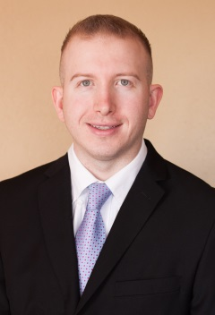
Brock C. Parker
442 SW Eastman Ct. Gresham, OR 97080
EDUCATION________________________________________________________________________________________
Portland State University
Bachelor of Science (Organismal Biology, Pre-Medicine) September 2007 to June 2012

EXPERIENCE____________________________________________________________________________
Anesthesia and Perioperative Medicine, Oregon Health & Science University Portland, OR Anesthesia Tech May 2013 to Present
- Assist with induction of anesthesia and line placement including arterial lines, central lines, and pulmonary artery catheters.
- Trained in cardiac anesthesia where I scrub in and assist with line placements
- Certified on ABL90, cell saver, and Belmont for mass transfusion
- Respond to level one traumas and provide quality lifesaving resuscitation
- Take trauma and liver transplant call
- Turn over operating rooms which includes a detailed cleaning, stocking of anesthesia cart, and machine checks

Ambulatory Surgery Center, Kaiser Permanente Clackamas, OR
Volunteer November 2011 to Present
- Assist nurses with receiving patients from the operating room
- Obtain and record vital signs, maintain IV supply, prepare ice bags and warm blankets
- Discharge patients by safely transporting them from the facility to their car
- Observed anesthesiologist and surgeons in the operating room
- I would talk to the patients to make them feel comfortable, including patients that did not speak English
- Read and interpret electrocardiogram strips

Physical Therapy, Therapeutic Associates Portland, OR
Physical Therapy Aide September 2012 to March 2013
- Registered new patients and verified insurance information prior to service.
- Provided physical therapy treatments and modalities to patients under the supervision of physical therapists.
- Trained in using ultrasound therapy and electrical stimulation as a part of the patients therapy
- Communicated with MDs and insurance companies to verify the patients status and to continue treatment
- HIPPA trained and responsible for explaining the policy to patients

Portland Public Schools Portland, OR
Para-educator/ ESL assistant March 2005 to January 2012
- Served as an advocate for special education students
- Assisted physical therapist with therapy sessions for the students
- Assisted in ESL classrooms with fun activities and produced assignments.
- Instructed ESL students by initiating games that involved functional social conversational English.

