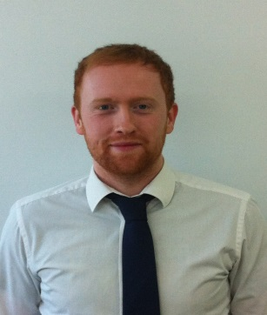
Chris Jones
London, England
Skype: chris.jones7069
chrisjones6437@yahoo.co.uk

I am a professional, well-organized and TEFL qualified English graduate who wishes to continue teaching English in Korea. I pride myself on delivering creative, engaging and interesting lessons to learners of the English language.
Work Experience

March 2013 – March 2014: Teacher - English Learning Bay, Sinwol Campus, Seoul, South Korea.

- Teaching English conversation, reading, writing and phonics and science classes to kindergarten and elementary school students. Teaching debate and public speaking to elementary school students.

- Teaching conversation classes using smart board technology to kindergarten and elementary students.

- Quality review of potential curriculum materials.

- Creating and delivering monthly lesson tests for students.

- Preparing and delivering open classes for all kindergarten and elementary classes.

March 2012 – June 2012: Tutor - London England.

- I tutored a 17 year old boy, Elis Gjegja, in his English International GCSE (IGCSE).

- English was his second language (ESL).

- My tutoring helped him pass the International GCSE exam, so he could go to University.

- Only tutoring him 3-4 hours of tuition per week I made the difference. A reference is available upon request.
Education

I was awarded a Bachelor of Arts in English Literature and Creative Writing in 2008 from Roehampton University in Surrey, England. Core areas I studied included:

- Essays and analysis of English Literature

- Essay and analysis of English Language

- Public speaking and presentation skills

- Creative Writing
Achievements/Awards

- I am TEFL qualified, having completed a 120 hour course with I-to-I.
- Proficient in many computer packages such as ACA and Microsoft office; including Word, Excel and PowerPoint.
- I have written as a freelance journalist for The Professional Footballers’ Association and RockFeedback music magazine.
- I hold an occupational First Aid certificate.
- Fire Safety – I am a trained Emergency Incident Warden/Fire Marshall. I can coordinate evacuations, building sweeps and post-incident review.

- Languages – I am studying Korean and can communicate at a basic level. I speak competent French and German.

Referees

Heidi Lee
Head of Education
English Learning Bay
Sinwol Campus, Seoul, South Korea

Telephone: +82-20-2692-0512

Ben Brock
111 Porchester Road
Norbiton
Kingston-Upon-Thames
KT1 3PW

Telephone: +447786-673-574
Email: b_d_brock@hotmail.com

