Hee Yeon Kim( Cathy Kim) 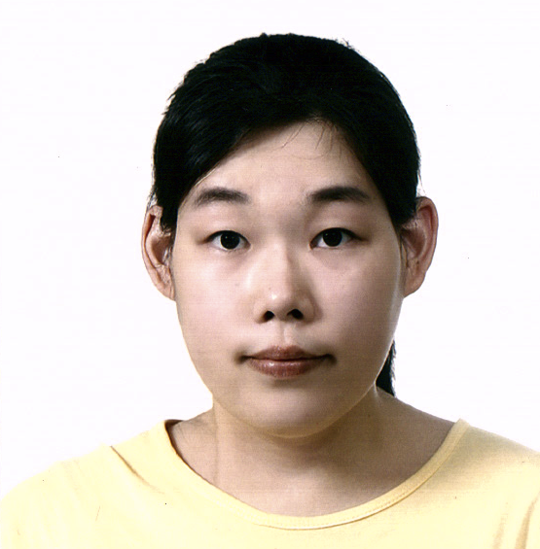

121-601 LLL’s apt
Songpa gu Jamshil 2dong Seoul, Korea 138-908
Education
1998.9~1998.12 |  | Roseville Area high school
1999.1~2003.5 |  | Korea Kent foreign school
2005.1~2007.1 |  | Santa Monica college | Early childhood Education | AA
2007.9 |  | California State University of Northridge | Early childhood Education | BA
 | Experience
2013.7~2014.2 |  | RIS | 4 year old teacher
2012.4~2013~7 |  | Artory | 6 year old teacher
2006~2008 |  | Arts and Craft Teacher | Star Education
2010.9~2011.5 |  | Internship Student | CSUN Child and Family studies Center
 |  | US Army base daycare center | Infant and toddler

Family
Father | Young il Kim | 60 | Professor
Mother | Nan hyo Kim | 60 | Housewife
Sister | Su yeonkim | 34 | Pharmacist

