박수잔 (Susan Park) 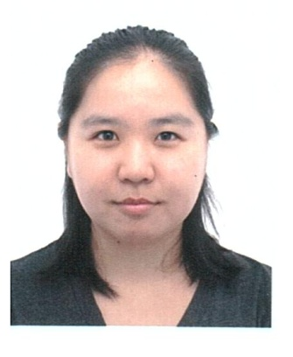
DOB 1983/09/01
Kyung Ki Do Seong Nam City Bun Dang Gu Sue Nae Dong
Yang Ji Village Han Yang Apt 525-1102
(경기도성남시분당구수내동양지마을한양아파트 525-1102)
010-4503-2281
Take904@hotmail.com

Qualification

I can speak, write, and read in English and Korean fluently in both languages. I granulated college in 2006 with a bachelor degree on Sociology. I am very organized, prompt, and active. I can provide accurate information, follow direct orders, multi tasks at one time. I am good with MS, Power Point, and Excel. I am cable of answering multi-phone call, write email, and fax. I have a strong passion for children. I love to play with children and explore adventures. With experience working with pre-kindergarten (2-4) for two years as a main Sunday school teacher and as well many years of tutoring English. I cooperate with different culture, language, age sex, education, job and etc...to serve them equally. I lived in Korea and the States and have experienced both cultures first handed. I have a very positive mind and a cute smile. I work diligently and promptly.

Education

Bachelor degree in Sociology 2002-2006
North Park University
3225 W. Foster Ave.
Chicago, IL 60625

Experience

- Office Manager/receptionist at a doctor’s office 2007 to 2011
Cosmo Health Care6185 Buford Hwy.Norcross, GA
I was an office manager/ receptionist at a private doctor’s office with three doctors and two nurses. I was in charge of claiming Medicare, Medicaid, and private insurance. I gave appointments to patients and answered all the concern and test procedures. Other responsibilities were to greet patients, cashier, clericalwork and etc…

- Sunday School teacher 2009-2011
Sae Han Presbyterian Church.Alpharetta, GA
I taught 3-4 years old children as a Sunday school teacher. For the first years, I was an assistant but after a year I became the head teacher. I was in charge of worship song and dance, Bible stories, crafts, snacks and etc…

