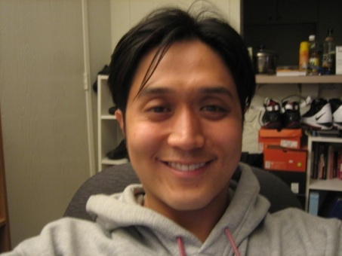

Jimmy Lee
So Bing Go-Dong, Shin Dong Ah 12-605 Yong San Ku Seoul Korea
Email: hiddenguy77@hotmail.com Mobile: 011 285 4514

Education
1984~1996  2001 ~2004 | Seoul International School  Santa Monica College | Seoul Korea  California U.S.A
2004~2006 | University of Los Angeles | California U.S.A

Highlights of qualification, Others

Interpreter for Korean actresses (이미숙, 최진실) during the visit in Los Angeles

Work Experience
Private Tutor
Part Time Tutor (2 Children) Preparation for 휴학. 4 hours a day. 3 times a week
Part time Tutor (1 adult) Business English, twice a week
June 1998~2000  Mar 2010~ |  | Seoul, Korea
March 2002~  Sept 2005 | Hak Won (6th and Study)  Managed teachers and the relationship between parents and the Hak Won | Los Angeles, U.S.A.
Prepared academic plans for classes
Coordinate and create new classes (이민: 어머니 반 영어)
Led the discussion among teachers during weekly meeting.
Location: Anywhere close to 시청역 number 2 line (강북)

Pay: part-time or full-time. (Negotiable)

Visa: Not needed, U.S. resident.

Hours: Can start after 12:00 pm

