 | Sheila Grace Bridgman
12/3/2010
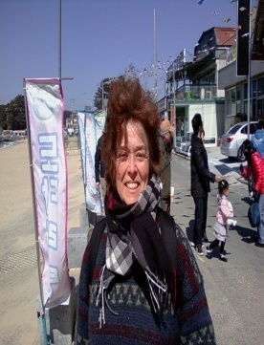 | Address: Apartment 903/23 Woodlawn Road East, Guelph,  Ontario, Canada NIH7G6  Cell number: 8377 0804  Email: bridgbit1@aol.com

Choose a building block.
work hISTORY/ EXperience:
ENGLISH TEACHER SOUTH KOREA:
Teaching all levels/ ages: individuals, small groups, large classes.

2009-2010 Chungnam Board of Education Boryeong City
2001-2003 Namseoul University Cheonan
2000-2001 Andong National University Andong City
1999–2000 E.C.C. Private School Anyang City
1996-1998 Juseoung College Cheong Ju City

PROFESSIONAL MUSICIAN:
String bass player in the following orchestras.
1978–1987 Canadian Opera Company Toronto, ON.
National Ballet of Canada Toronto, ON.
1987–1995 Piano Teacher Toronto, ON.

CAREGIVER:
Tutor, assist, train people with disabilities.
2005–2009 Walkerton Community Living Walkerton, ON.
2005–2009 Gassinger Home Durham, ON.

SELF- EMPLOYED:
Designed/manufactured musical instrument cases.
1985–1995 Grace Case Toronto, ON.

LEADERSHIP AND ORGANIZATION:

Acted as a role model for students in personal presentation and enthusiasm for learning.
Used time effectively to set and achieve goals, determine realistic priorities and work to deadlines.
Demonstrated creativity in lesson implementation.
Worked co-operatively planning and implementing programs for students.
Presented education programs to suit the varying cognitive levels, backgrounds and ages of students.

EDUCATION:
1998 TESL Certificate Benn’s International School
1992–1995 Bachelor of Fine Art York University
1995-1996 Teacher Education Nipissing University
1988–1991 Creative Arts Diploma Georgian College
1974–1977 Diploma Music Performance University Toronto

REFERENCES:
Okkye Elementary School, Boryeong, South Korea
Vice Principal, Kim Jong Soon, Ph:041-936-7172
Co- teacher, Mrs. Jang, Ph:016-415-9161
Chang Ra Elementary School, Boryeong, South Korea
Principal, Han Sang Yoon, Ph: 041-932-8038

