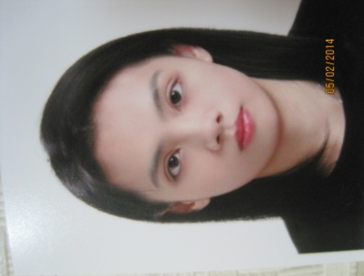

이름 | 케롤라인 디아젠 | 영문 | Caroline Diazen
주민번호 | 861009-6101790 | 나이 | 29
휴대폰 | 010-2240-7025 | E-mail Address | rhaven1009@yahoo.com
주소 | 서울시 서대문구 부가좌2동 295-21/ 마곡역에 이사할겁니다.

Objective:
- To obtain an English Teacher position where I may employ my knowledge of the English language along with pertinent resourcefulness to truly make a difference in young children’s academic life
- Looking for an English Teacher position utilizing my English language skills and classroom management abilities in order to provide a conducive learning environment

학력사항(최종학력: 대학교(4년)- 졸업
재학기간 | 학교명 및 전공 | 구분
2003년 - 2007년 | University of Baguio  Major: Bachelor of Science in Nursing(BSN) | 졸업
1999년 - 2003년 | Baguio City National 고등학교 | 졸업

경력
기간 | 활동내용 | 활동구분 | 기관 및 장소
2007년 ~ 2009년 | A-Plus English Language School | 영어강사(Full-Time) | Baguio City
2009년 ~ 2010년 | Baguio English Special Tutorial | 영어강사(Full-Time) | Baguio City
2014년01월-2014년7월 | 어린이집/유치원 | 영어 강사(Part-time) | Seoul/Ilsan

Relevant Experience:
- I taught phonics, story telling, brainstorming, games/ activities, song and chants, english communication enhancement for kindergarten students.
- As classroom teacher, built rapport with students from a wide range of cultural backgrounds.
- Created trusting atmosphere through sensitivity to students' strengths, weaknesses, and personal learning styles.
- Engaged students through humor and activities designed for maximum interaction in large and small groups.
- Developed curriculum that was appropriate to students' learning abilities and reflected their needs and interests.
- Create an entertaining way of learning and encourage students to apply it on their daily lives.

