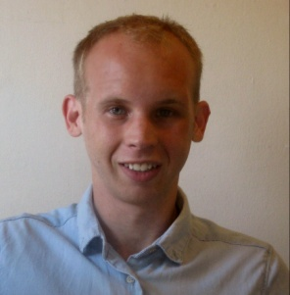
MATTHEW CONFER
411 11th Ave E. Apt. #305
Seattle, WA 98102
matthew.confer@gmail.com
(843) 906 - 2235
Skype ID: matthewconfer
____________________________________________________________________________________

OBJECTIVE:
Seeking a position TESOL in South Korea

EDUCATION:
University of South Carolina, Columbia, SC, 2008
Bachelor of Arts
- Major: Art Studio
- Emphasis: Drawing
- Academic Honors
- GPA: 3.5

S-TESL certificate in Teaching English to Speakers of Other Languages, Seattle, WA, 2011
- Completed a 120-hour Post-Baccalaureate twelve credit-intensive TESOL training course at S-TESL, a Seattle University accredited program

EXPERIENCE:
Volunteer Experience:
World Relief, Seattle, WA, 2011 – Present
- Provided small group and one-on-one ESL assistance to adult refugees seeking to integrate themselves into the United States on a weekly basis
Seattle Works, Seattle, WA, 2010
- Volunteered in a variety of community based efforts on a monthly basis

Work Experience:
Safeway, Courtesy Clerk/Stocker, seasonal work, Seattle, WA, 2009
- Bagged groceries and took customers’ purchased goods to their cars
- Stocked groceries and faced on shelves during night shift
- Provided back up courtesy clerk and stocking services for absent workers
- Cleaned up store, emptied garbage, and swept floors

Piggly Wiggly, Assistant Manager, Product, Summerville, SC, 2002
- Promoted to Assistant Produce Manager after 5 months
- Performed opening and closing duties
- Assisted customers in finding merchandise
- Organized produce shelving and marketing displays

ADDITIONAL SKILLS:
- Typing at 50 WPM
- Proficient in MS Excel, MS Word, MS PowerPoint
- Proficient in Photoshop, Illustrator

