Genevieve M. Tecson
Yongin City Suji Gu, Pongdeokchon 1 dong Tongbu Apartment 103-602
Tel: 010-4159-3294 E-mail: sky_bae@yahoo.com
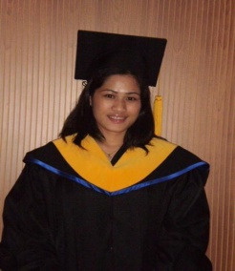
OBJECTIVE:
Students learn different learning style in my teaching on English as second language.
Students will be learned not only in the book of knowledge but also in the life knowledge.
SPECIAL SKILL: Good in both written and oral communication, highly develop in personal relations.
EDUCATION
July 03, 2009 Winglish Tesol & Biz Education Center University Of California, Riverside University Extension.
Yoochang Bld 10th floor 1305-7, Seocho-dong, Seocho gu,
Seoul, korea
TESOL Certificate

March 25, 2002 Bachelor of Science Information Technology. (IT)
Acts College of Technology
Davao City Philippines
LANGUAGES
English , Tagalog and Korean.

PERSONALA DATA:
Provincial Address :Davao City
City Address :Davao City
Date of Birth :June 04, 1983
Age :26 years old
Nationality :Filipino
Civil Status :Married
Religion :Roman Catholic

Hi I am Miss Genevieve Tecson F2 visa holder . I am certified tesol holder.I saw your add at English Spectrum today. I have 1 year experienced in teaching into elementary level. I am very hardworking, patients, punctual, and really love dealing with kids and because of that I know how to handle them in a nice way. I choose this vocation because I want to share my knowledge specially to the ESL students.

If you think that I am capable in this kind of position please don’t hesitate to call me or email me, I can start as soon as possible.

Thank You,
Genevieve Tecson

