Yvonne Tran
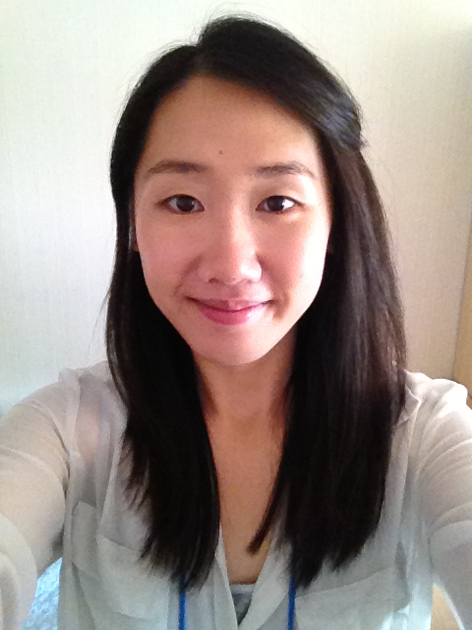
D.O.B: 1989/09/11
Seoul
South Korea

Personal aim:
A passionate native English teacher (not Korean) from the UK. Have 1.5 years of teaching experience in Jeju-do. During my time in Korea, I have really enjoyed teaching. It is very rewarding to watch students learn and grow. I am looking for a new challenge for a new teaching position in the city of Seoul. Previously had E2 visa, but now changed to D10 Visa.
Education: University of Central Lancashire (graduated in July 2013)
BA Honours degree English language and linguistics and Chinese Grade 2:1
English modules:
- Foundations of English Grammar
- English in Education
- Child Acquisition
- Language and Gender
Additional modules:
- Essential Skills for a Career in Teaching
Employment:
TaLK English Teacher Sagye Elementary School (Jeju-do) Sept 2013 – July 2014
TaLK English Teacher Bukchon Elementary School (Jeju-do) Sept 2014 – Jan 2015
- Planned and taught 3-4 classes daily:
  - After-school English classes for grades 1-6
  - Curriculum classes for grades 3 - 6.
- Planned and taught day-care classes for grades 1 – 2.
- Planned and taught winter camp for grades 3 – 6.
- Prepared classes using provided textbooks and personal teaching materials including PowerPoints and worksheets.
- Focused on improving students’ grammar, listening, speaking and writing skills.
Training:
TaLK Orientation Elementary after-school training Aug 2013
Certificate of completion.
3 weeks intensive training with lectures on the following topics:
- Teaching Methodology
- Classroom and behaviour management
- Lesson planning and creating materials
- Practicum’s on solo – teaching and co – teaching

- TaLK In-Service Training online course – 15 units.

Referees:
- Referees available upon request.

