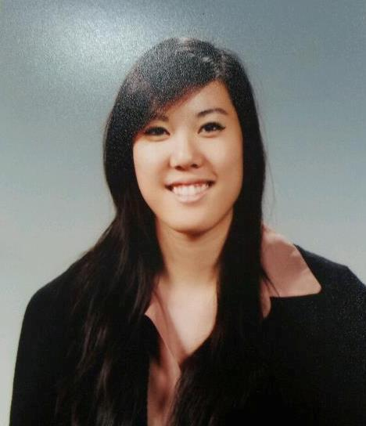

VIRGINIA LEW

SKILLS SUMMARY
- Reliable and detail-oriented worker
- Strong leadership, communication and interpersonal skills; works well with people of all ages
- Fast learner, adaptable and versatile
- Knowledgeable of computers and Microsoft Office Programs (particularly Power Point, Excel, Word)

CERTIFICATIONS
2011 Seoul Metropolitan Office of Education Co-teaching Training Program
2011 English Program in Korea Orientation Program

2010 Teaching English as a Foreign Language (TEFL) (100 hours)

EDUCATION

2012 – Present UTAH STATE UNIVERSITY

Seoul, South Korea
- Non-degree seeking student in Department of Communicative Disorders and Deaf Education
- Currently enrolled in Online Post Bachelor’s Program to complete prerequisite courses for application to Masters of Science Program in Speech Language Pathology
- Maintaining >90% (A letter) grade in all courses completed and in progress

2007 – 2011 QUEEN’S UNIVERSITY

Kingston, ON, Canada
- BSc Biology General (October 2010); BScH Life Sciences Major (June 2011)
- Queen’s University Entrance Award (2007); Millennium Scholarship (2008)

2004 – 2007 HENRY WISEWOOD SENIOR HIGH SCHOOL
Calgary, AB, Canada
- International Baccalaureate Certificate Program; graduated with honours
- Alexander Rutherford Scholarship (2007); Mary McIntyre Outstanding Service Award (2007)

RELEVANT EXPERIENCE
Aug 2011 – Present NATIVE ENGLISH TEACHER
Seoul Samkwang Elementary School
Seoul, South Korea
- Develop innovative and stimulating lesson plans to teach English as a foreign language to elementary school students; conduct lessons alongside a Korean English teacher
- Create original lesson materials for lessons
- Implement classroom management techniques to maintain a positive learning environment
- Design and teach a creative curriculum for Grades 3-6 English camp every semester
- Organize and judge school English events such as Speech Contests and Essay Contests
- Design layout and content of ET (English Textbook) Day booklets for students (Grade 3-6) participating in a dialogue-memorization contest

Aug 2012 – Present ENGLISH TUTOR
Seoul, South Korea
- Tutor middle school student in reading comprehension, vocabulary improvement, conversation, and TOEFL Junior preparation
- Tutor prospective graduate student in preparation for graduate school interviews with graduate programs in the United States
- Tutor adult students for improvement in English conversation and comprehension

Sep 2004 – Aug 2009 PIANO TEACHER
Canadian Academy of Music (2004-2007); Private Instructor (2008-2009)
Calgary, AB, Canada
- Taught piano and rudimentary theory to children of all ages and adult students
- Acquired valuable interpersonal skills in dealing with students, parents and other teachers

Sep 2007 – Jun 2008 MATH AND SCIENCE TUTOR
HYPE Tutoring
Kingston, ON, Canada
- Volunteered as a tutor for high school students in Chemistry, Biology and Math

INTERESTS Piano, badminton, volleyball, jazz dance, break dance, hip hop dance

REFERENCES Hyuna Kim (김현아 선생님)
English Teacher
Seoul Samkwang Elementary School
Seoul, South Korea
010-9472-1598

