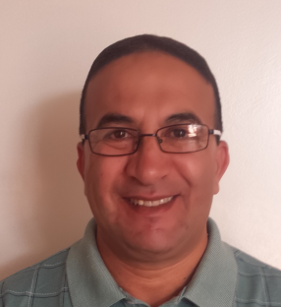
Mostafa Diouane
US CITIZEN
msdiouane@hotmail.com / Skype ID : agadiroufala2008
Cell phone (968) 97461970

ESP / ESL /IELTS TEACHER
Highly experienced ESP/ ESL / IELTS teacher has educated hundreds of non-English speakers in English fundamentals, basic grammar skills, English literature, and complex terms, over 35 years Teaching experience.

Qualifications Summary:
Notable competencies include:
- Ability to use pedagogical methods and practices to achieve high quality results.
- Skilled in communicating with varied audiences of cultural diversity.
- Highly effective writing/verbal and interpersonal skills.
- Extensive experience in designing curriculums.
- Constant desire to raise English language level of the students.
Other Significant Skills:
- Orienting and organizational skills.
- Data management and basic computer literate
- Translator/Interpreter for some multinational companies in Morocco (Arabic-French-English)
- Coordinator and organizer of many cultural activities for my students with some foreign cultural centers in Morocco.
- Former camp counselor for mentally and disabled kids in USA during the two summers 87 and 88
- Ability to work on Smartboards

Employment Experience:
- Currently residing in Muscat and I am in search of an available teaching position.
- Teacher and IELTS Trainer at Hawthorn Language Center in Sohar 2016 - 2017
- Teacher of English and Acting Center Director for ELES in Sohar. 2014-2016
- In Oman : Teaching government employees, Royal Oman Police , RAFO , Consumer Protection
- ESL Instructor at Cal State University of Bakersfield (CSUB) CA, USA 2003-2014
My Students were from China, Japan, Saudia Arabia, Middle East
Africa, and Latin America.

- Director of New Business English School in Casablanca 2000-2003
- Teacher of English for the Ministry of Education in Morocco 1984-2000
- IELTS Certified Teacher
- Interpreter / Translator for several institutions and companies in USA and Morocco
( Arabic-French and English)

Professional Work:
- Helping in designing appropriate curriculum and programs, keeping in mind students’ levels and goals.
- Helping in designing creative and didactic programs that are both educational and enjoyable.
- Briefed students with written presentations and explanations to raise awareness of cultural aspects as well as language.
- Directed classroom activities and maintained proper decorum in class.
- Held responsibility of guiding students facing difficulties in their studies.
- Acted as student counselor before and after classroom sessions.

Educational Qualifications:
- Bachelor’s degree in English or Education from Ecole Normale Superieure in Rabat, Morocco (1991-1993)
- Teaching Degree from Centre Pedagogique Regional CPR, Rabat, Morocco (1982-1984)
- Training Trainees IELTS Certificate from British Council in Muscat 2016
Languages:
Fluency in Arabic, French and English

