Thomas Joshua Clark
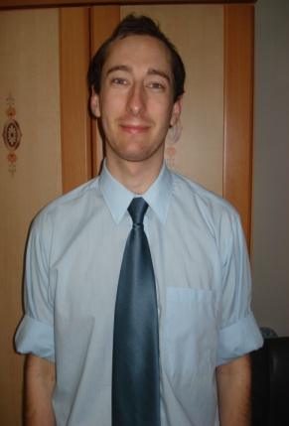
7 Regatta Court
76 Undercliff Gardens
Leigh-on-Sea
Essex
SS9 1ED

Date of Birth – 10/10/1984

Email – tomclark5@hotmail.com

Telephone – 00441702479114 or 00447901969966

Nationality – British

Gender – Male

Date of Availability – August 2010

Education

The University of Birmingham,  Edgbaston, Birmingham, B15 2TT, UK  Tel: +44 (0)121 414 3344 | 2005 – 2008 | BA Hons Sport, Physical Education and Community Studies BA  Upper 2:1 class  First class marks awarded for modules focusing on disability access to sport in the UK. | At University my academic studies were supplemented by my work as student representative, responsible for liaising between my fellow students and academic staff.  I was also nominated for the role of Sports representative for my year group.  In my final year my studies were focused around a 16,000 word dissertation entitled “A Case Study into the Provision and Accessibility of Sporting Facilities for Disabled Adults”.
Bishops Stortford College,  10 Maze Green Road  Bishop's Stortford  Hertfordshire CM23 2PJ | 2001 – 2003 | 2 A Levels  English Literature C  Physical Education B  3 AS Levels  History C  Media Studies C  Psychology D  As a school leaver I was awarded the Arthur Evans Tie, a prize that recognizes all round excellence in many aspects of school life. | Whilst at School I took part in a wide variety of sporting activities.  I was also involved organising and running events at the school for the benefit of children form less privileged backgrounds, including fundraising and the staffing of the activities.
Westcliff High School for Boys  Kenilworth Gardens  Essex SS0 0BP | 1996 – 2001 | 10 GCSE’s at Grade C and above  English Language A  English Literature B  Maths B  Science B | Whilst at high school I took part in a wide range of sport activities and was fortunate enough to begin my love of world travel by a trip to Australia after the completion of my GCSEs.

Employment History

YBM SISA English to Children Currently  February 2009 – February 2010  Position held: English Teacher | My most recent position was as an English teacher at a well respected and long running English Academy in South Korea. The main aspect of my position was to teach children aged between 6 and 13 English language, reading, writing and conversational skills. I taught on average 6 classes of 50 minutes per day, from a variety of textbooks, including English Playground, English Carnival, English Wakeup, Speaking for Everyday English and English Phonics. Outside teaching my responsibilities included: lesson planning, setting and grading tests, phone teaching to all students and writing monthly evaluations.
Birmingham City Council – Customer Relations Service, Adults and Communities Directorate  May 2008 – February 2009  Position Held: Clerical Assistant  Duties and Experience | The job role involved undertaking work processing and tying tasks, providing a reception service, organizing, attending and minuting meetings, I was responsible for the allocation and distributing of complaints to managers, assisting in the administering of complaints involving the Local Government Ombudsman and managing the maintenance of filing and archiving systems for complaints.
Southend Adult Community College and Dolphin Court Residence -  February 2008  Position Held: Research Student | This placement was part of my dissertation which was “A Study Into The Provision and Accessibility of Sporting facilities for Disabled Adults.” I observed, interviewed and used questionnaires as a method of data collection. I was involved with both able bodied and disabled people as well as from many different ethnic and religious backgrounds.
The Deanes School  January 2007  Position Held: Research Placement | A research project as part of my degree. This project was at a specialist sports college and I was researching the Long Term Athlete Development scheme. I was directly involved with children between the ages of 9 and 11, with the use of questionnaires and interviews for the collection of data.
Sportacular –  June – September 2002  June – September 2003 | Group leader at a children’s sports holiday organisation. Involved in running activities and caring for the children involved.
Kampala Kids League, Uganda  September 2003 – August 2004 | Kampala Kids League is a charity involved in sports and health education in Uganda. KKL is a charity affiliated and partly funded by Unicef (The United Nations International Children's Fund). I was a volunteer worker, where my main roles were fundraising, administrative work, coaching sport and teaching English.

