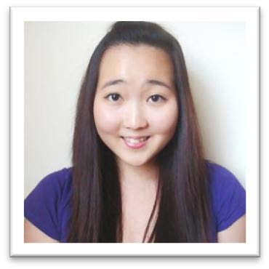

Subin Sohn

D.O.B.: November 1, 1990
Gender: Female
Marital Status: Single
Citizenship: United States of America
Current residence: South Korea
Visa Status: F4
Languages: fluent in English and Korean, elementary Spanish

PROFILE
Bilingual Korean-American with a bachelor’s degree in biology. Experience teaching to children as young as 2 years to 18 years of age. Planned and taught lessons in English (reading, writing, speaking), math (basic mathematics to pre-calculus), and science (chemistry, biology). Loving heart and open mind towards children of all ages.
OBJECTIVE
To work as an English instructor in Korea to help children with English.
EDUCATION
THE OHIO STATE UNIVERSITY, Columbus, OH, United States
Bachelor of Science – Biology September 2009 – June 2012
RELATED TEACHING/WORK EXPERIENCE
JPC ACADEMY Columbus, OH, United States
Tutor June 2011 – November 2012
• After school tutoring program for ages 8-18
• Duties include:
o Tutoring students in math, English, and science
o Planning individual lessons tailored for the student’s needs
o Distributing weekly assessment of skills to track progress
o Overseeing individual study time and answer questions on homework assignments from school

KOREAN CHURCH OF COLUMBUS Columbus, OH, United States
Sunday School Teacher June 2005 – November 2012
• Responsible for ages 2–5
• Duties include:
o Leading the children in praise
o Conducting bible study in individual classes
o Assisting the young children with lunch
o Other duties as directed

Coordinator for Vacation Bible School 2010 – 2012
• Vacation Bible School is for children ages 2-15 and is conducted for one week in the summer
• Duties include:
o Planning the schedule for the week
o Overseeing decorations and coordinating necessary supplies
o Leading the children in praise
o Conducting bible study in class
o Being a contact between the teachers, students, and parents

UPPER ARLINGTON HIGH SCHOOL Columbus, OH, United States
Peer Collaboration September 2007 – June 2009
• Duties include tutoring students, helping new students adjust to school, and miscellaneous duties as directed
• In 2009, planned and coordinated service event for group of 20 students; involved contacting the service site, arranging transportation, gathering the student group, and leading the group at the site

QUALIFICATIONS SUMMARY
• Great organizational skills
• Reliable and enthusiastic
• Patient when working with children
• Diligent worker and quick learner
• Experience with a wide range of age groups
• Strong grammatical skills
• Excellent leadership qualities
• Genuine interest in enriching children’s minds
• Attended elementary, middle, and high school in the U.S.
• No accent when speaking English

AVAILABLE DOCUMENTS AND REFERENCES
•
• Original diploma
• Unofficial transcript (Official transcript can be requested; the transcript is processed within one business day, mailed via FedEx and delivered in two to three business days)
• F4 Visa
• Passport

