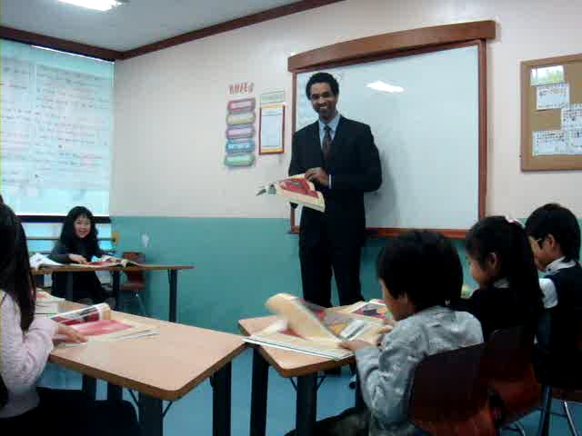

Personal Details (인적사항)

Address: | Po Box 13853  San Luis Obispo, CA | Date of Birth: | 06/06/1978
Telephone: | 010 2472 2453 | Nationality: | U.S.
E-mail: | callwoodj@hotmail.com | Marital Status: | Single

_____________________________________________________________________________________________________________________________________________________________________________

EDUCATION (학력사항)
California State University, Chico, CA
B.A. Degree, Communication Studies, Major: Organizational Communication June 2004
♦ Activities: Track and Field - Pole Vault (competition best 15’6”), Intercollegiate Cycling: Mountain Biking
♦ Honors: Collegiate Cycling Nationals Qualifier in downhill & dual slalom events, 2002 & 2003
Cycling Team National Ranking Division I 5th place, 2002

Cuesta College, San Luis Obispo, CA
A.S. Degree, Associates of Science, June 2008
♦ Activities: Track and Field, Coached Pole Vault, 2000-2001
♦ Honors: Member of Athletic Honor Roll, 2000
♦ Achievements: Top Ten Ranking for Pole Vaulting Statewide, CA Community Colleges, 2001
5th Place in So. CA Community College Pole Vault Championships, 2000

TESOL Training International, San Diego, CA
Advanced TESOL Certificate with a specialization in Business English (120 hours) June 2009
__________________________________________________________________________________________________________________________________

EXPERIENCE (경력사항)

English Instructor
Korea Herald, Incheon, South Korea Oct 2009 to Current
♦ Follow a school provided curriculum focusing on all areas of English language learning.
Pyeongtaek University, Seoul, South Korea July to Dec. 2009
♦ Instruct special intensive English classes focusing primarily on listening and speaking.
Korean Christian University Camp, Seoul, South Korea Jan. to Feb. 2009
♦ Conducted lessons that focused and enhanced the four macro skills of the English language.
♦ Used interactive teaching and group performances to excite and further stimulate interest in learning.
AA Korea (AAK), Seoul, South Korea Oct. to Dec. 2008
♦ Successfully educated students through various curriculums provided by myself and the company.
♦ Prepared Korean English teachers aged 27-55 for the IELTS test as well as their TESOL certification.
ChungDahm Institute (CDI), Seoul, South Korea May to Sept. 2008
♦ Instructed young learners aged 7-13 at one of South Koreas most prestigious English language schools.
♦ Taught classes using various multimedia and interactive activities

Co Manager
84 Lumber Co., San Luis Obispo, CA May 2005 to Feb. 2007
♦ Managed budget, payroll, areas of responsibilities, deliveries, etc, in a store grossing $5 million annually.
♦ Maintained and merchandised inventory, loaded/unloaded trucks, managed and trained employees at my store and others.
♦ Created material estimates from blueprints and maintained a personal Trade Relations Program for myself and employees.

Banquet Staff
The Gardens of Avila Restaurant, San Luis Obispo, CA Aug. 2001 to Jan. 2002
♦ Provided quality service in a high-pressure, fast-paced environment. Filled customer requests with cheerful efficiency.
♦ Set up and catered banquets for a variety of special events for up to 80 customers at one time. Bussed tables as needed.

Salesperson
The Sears Roebuck & Co., San Luis Obispo, CA June 2001 to Jan. 2002
♦ Earned silver name badge honor for achieving 100% customer satisfaction rating.
♦ Provided merchandise information and assisted customers in making purchase decisions in order to increase sales and customer satisfaction. Handled money and accurately maintained cash register balance.
♦ Set up store displays and promoted selected items for reaching company goals.
______________________________________________________________________________________

Computer Skills (컴퓨터능력)
♦ I have various levels of experience with Windows, Office, Networking, HTML coding, and Video & Photo Editing.

